**LAB-1**

**Database Assignment 1:**

1. 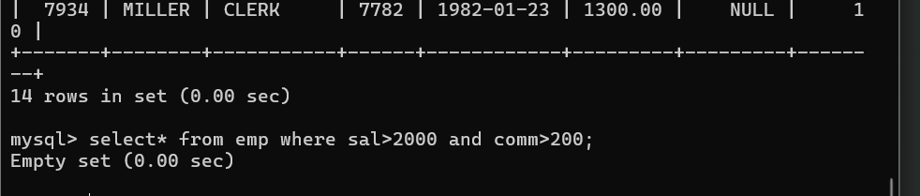To list all records with sal > 2000 and comm>200:
2. 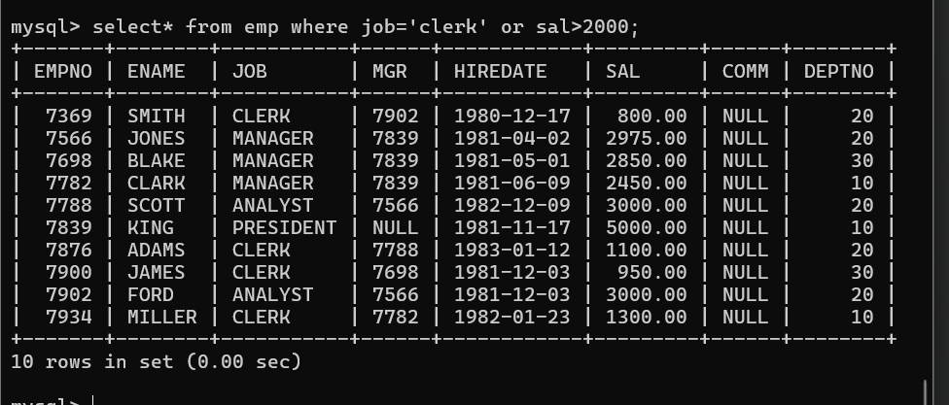To list all record with job=’Clerk’ or sal>2000:
3. 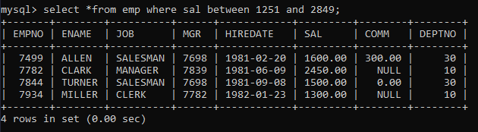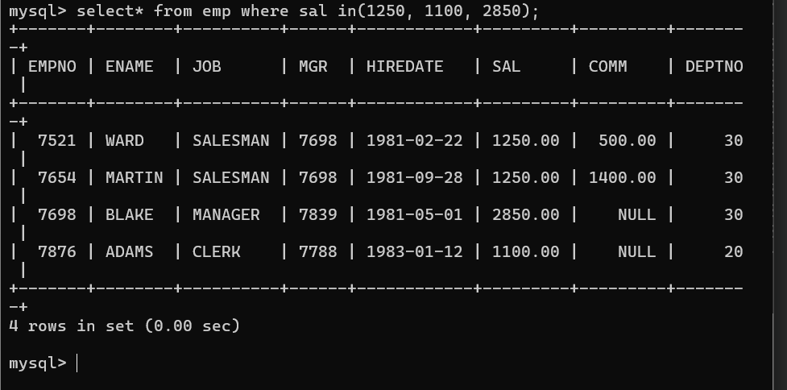To list all the record with sal=1250 or 1100 or 2850:

1. To list all employees with sal>1250 and <2850:
2. To list all employees with name ends with AS

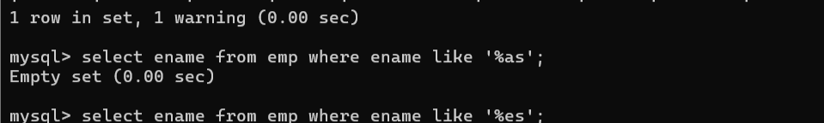

1. To list all employees with job starts with C and ends with K

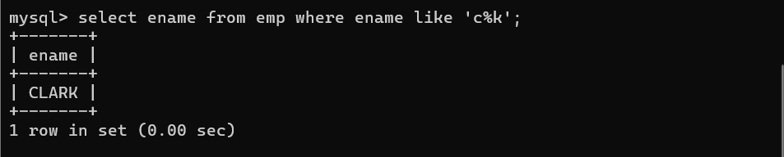

1. 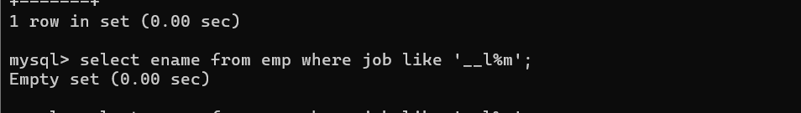To list all employees with job contains L at third position and M at third last position

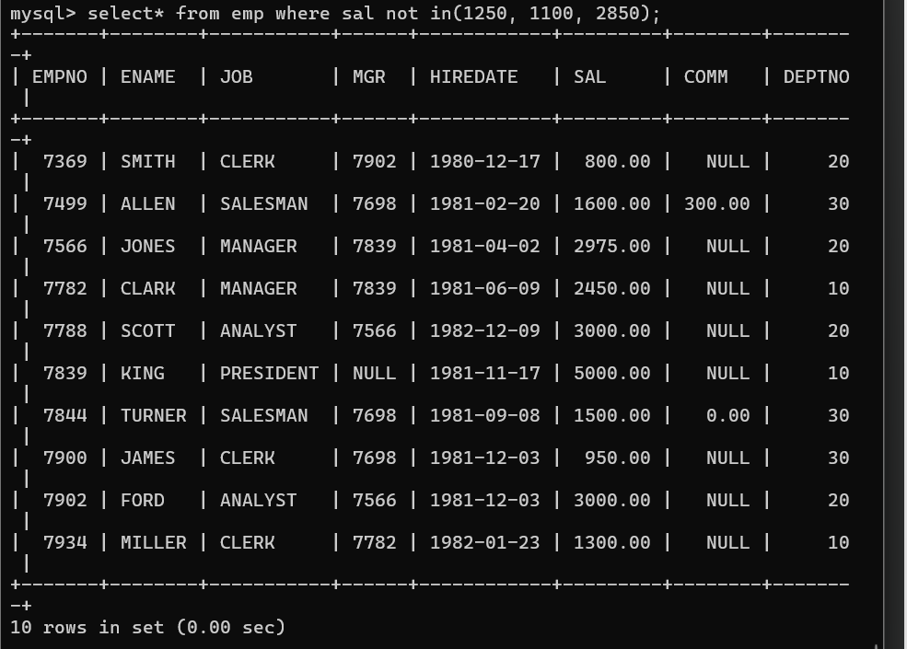8. To list all the record with sal not equal to 1250 or 1100 or 2850:

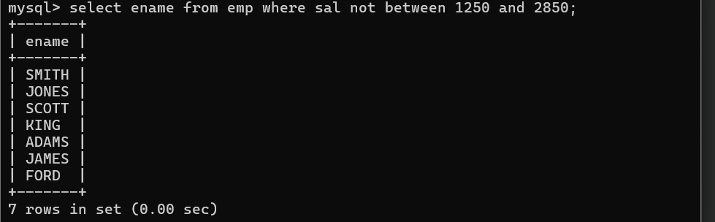9. To list all employees with salnot >1250 and <2850:

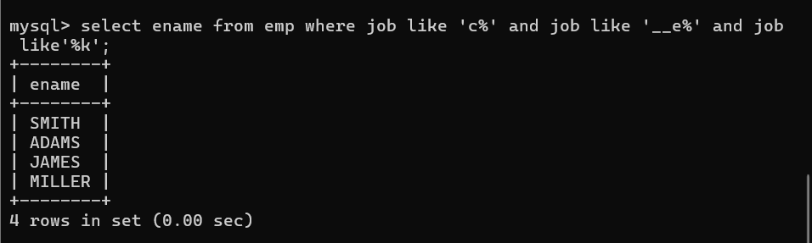10. To list all employees with job starts with C , E at 3rd position and ends with K:

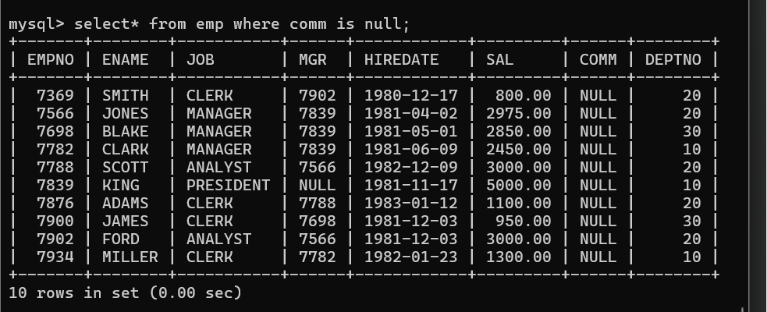11. To list all rows with comm is null:

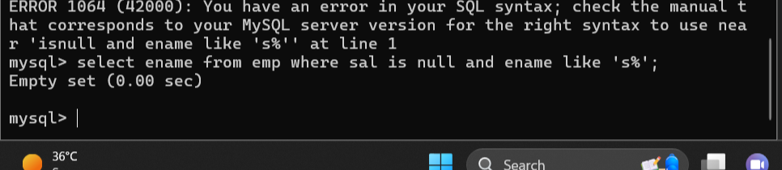12. To list all employees with sal is null and name starts with ‘S’

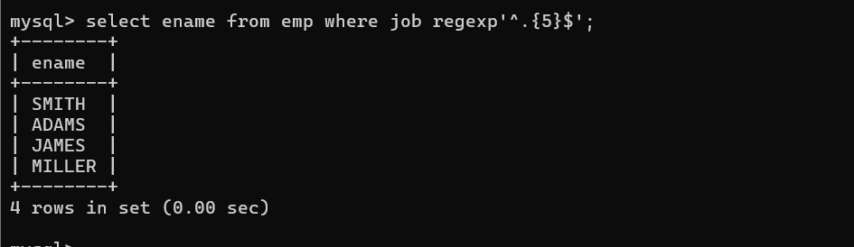13. To list all employees with job contains 5 characters:

14. To list all employees with name contain ‘A’ at 1 position and job .Contains 5 characters

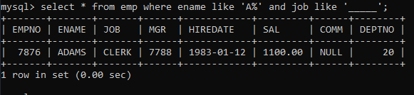

**Q2. Solve the following**

1. Retrieve the details (Name, Salary and dept no) of the emp who are working in

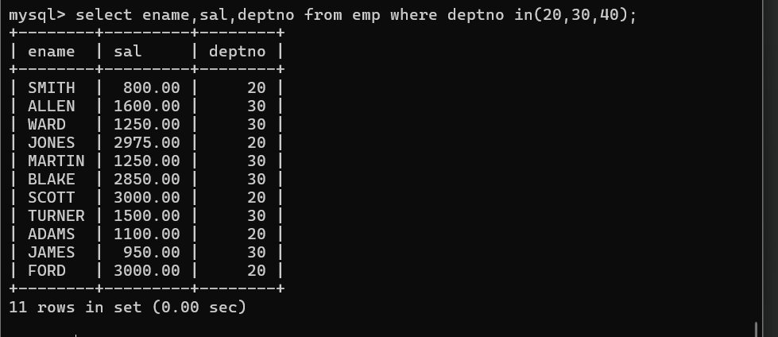department code 20, 30 and 40.:

2. Display the total salary of all employees . Total salary will be calculated as

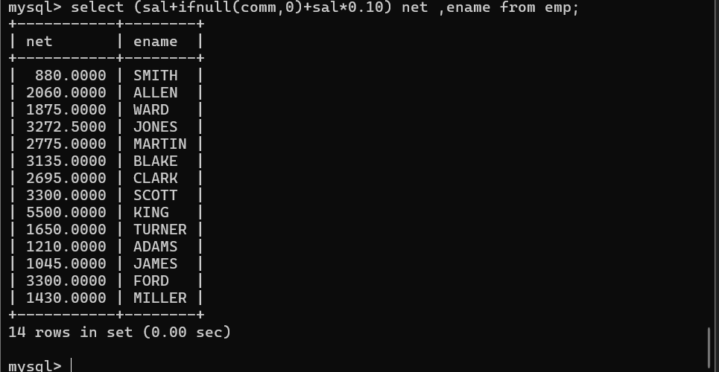sal+comm+sal*0.10

3. List the Name and job of the emp who have joined before 1 jan 1986 and whose

salary range is between 1200and 2500. Display the columns with user defined Column

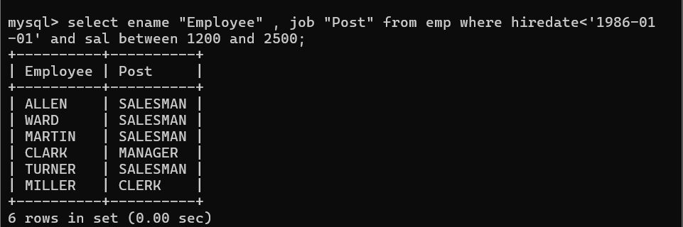headers.

4. List the empno, name, and department number of the emp works under manager

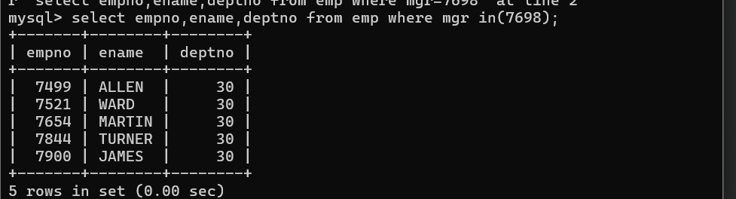with id 7698:

5. List the name, job, and salary of the emp who are working in departments 10 and

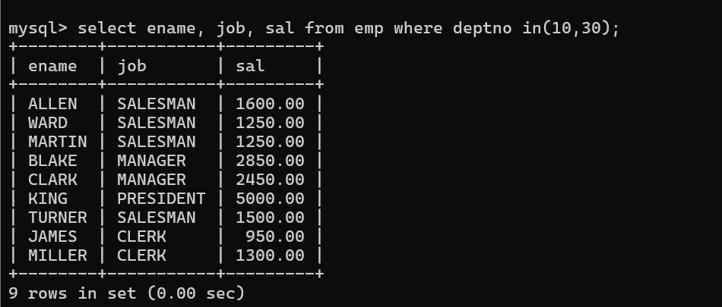30.

6. Display name concatenated with dept code separated by comma and space. Name

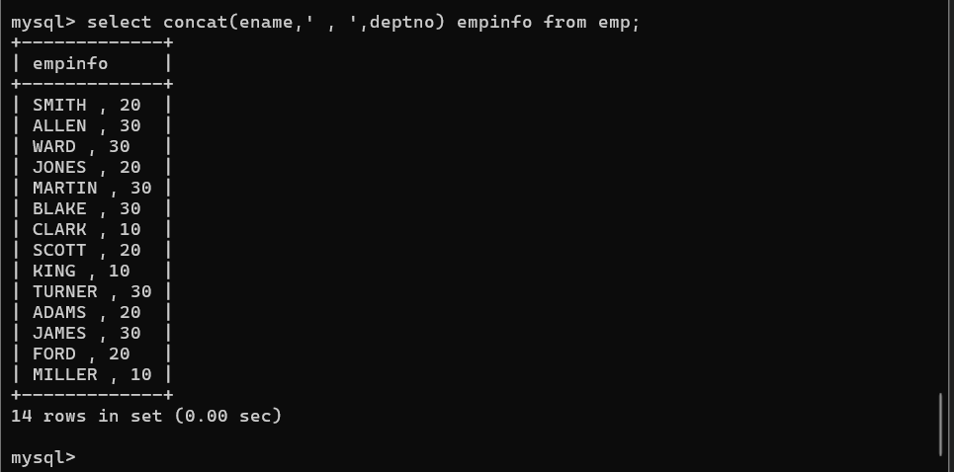the column as ‘Emp info’.

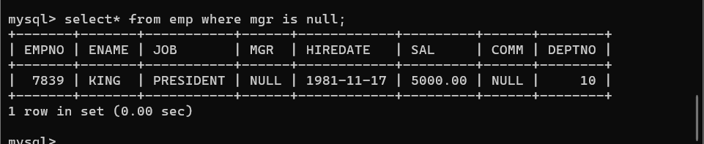7. Display the emp details who do not have manager.

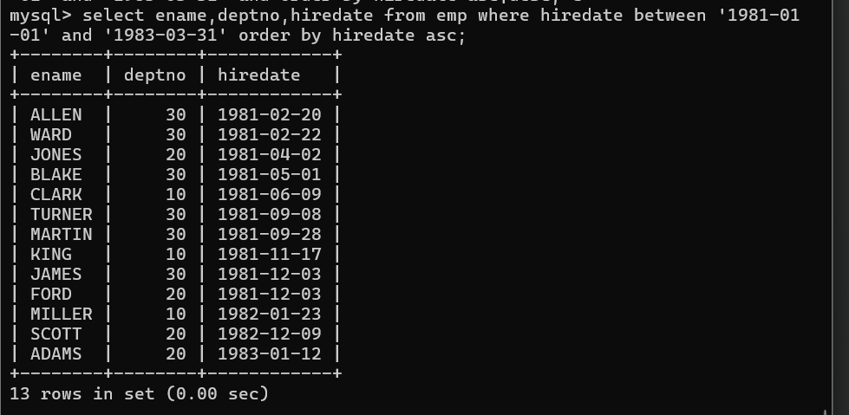 8. Write a query which will display name, department no and date of joining of all employee who were joined January 1, 1981 and March 31, 1983. Sort it based on date of joining (ascending).

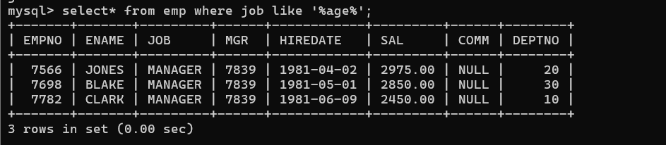9. Display the employee details where the job contains word ‘AGE’ anywhere in the Job

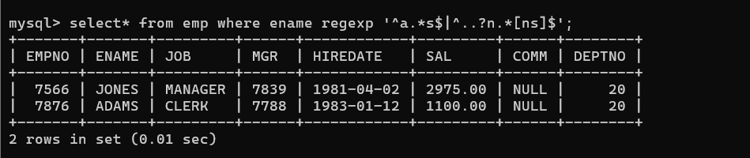11. List the details of the employee , whose names start with ‘A’ and end with ‘S’ or whose names contains N as the second or third character, and ending with either ‘N’ or ‘S’.

1. List the names of the emp having ‘_’ character in their name.

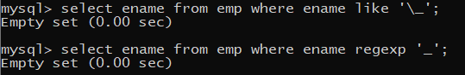

**Single Row functions**

1. To list all employees and their email, to generate email use 2 to 5 characters from ename

Concat it with 2 to 4 characters in job and then concat it with ‘@mycompany.com’

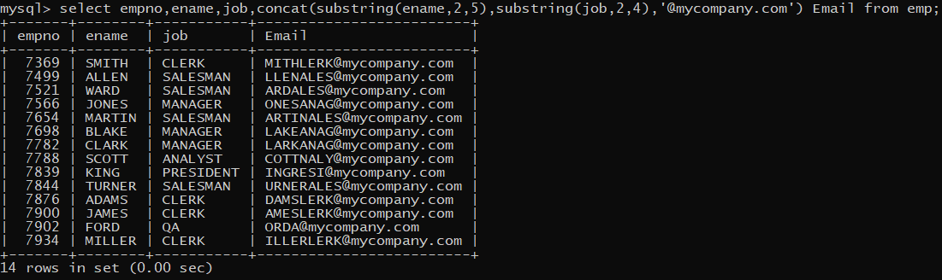

2. List all employees who joined in September.

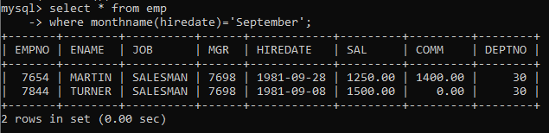

3. List the empno, name, and department number of the emp who have experience of 18 or more years and sort them based on their experience.

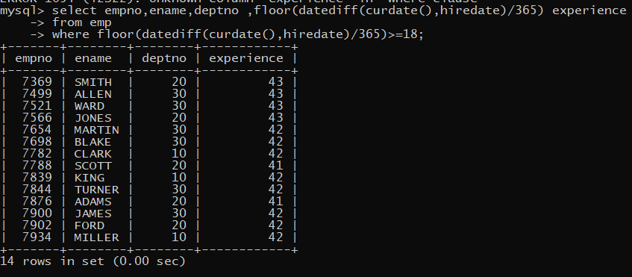

4. Display the employee details who joined on 3rd of any month or any year

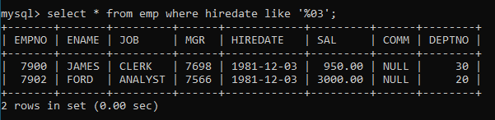

5. display all employees who joined between years 1981 to 1983.

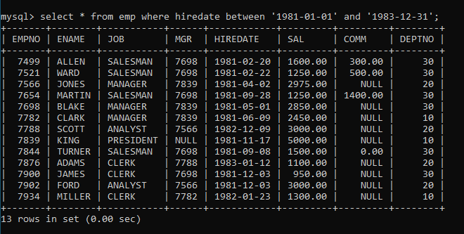

**Group functions**

6. Display the Highest, Lowest, Total & Average salary of all employee. Label the columns Maximum, Minimum, Total and Average respectively for each Department. Also round the result to the nearest whole number.

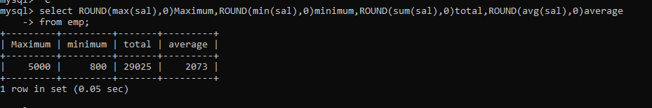

7. Display Department no and number of managers working in that department. Label the column as ‘Total Number of Managers’ for each department.

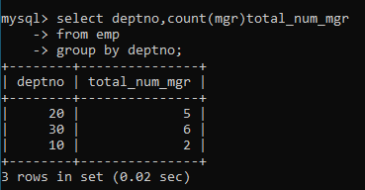

8. Get the Department number, and sum of Salary of all non managers where the sum is greater than 20000.

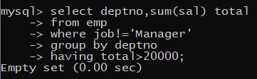

1. display all suppliers who statys in state either in california or Texas or Arkansas.

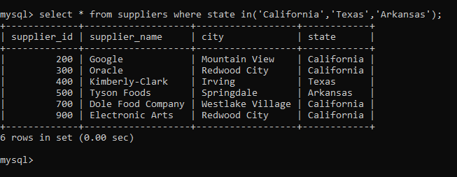

2. find all suppliers with supplierid >=200 and <=700

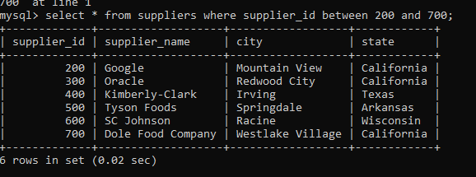

3. find all suppliers with supplierid not >=200 and not <=700

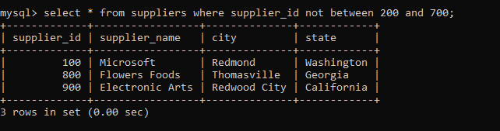

4.list all suppliers who does not stay in Springdale

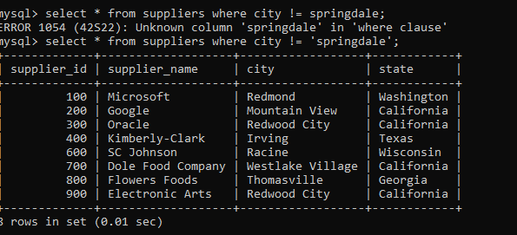

5.find orderid and customerid for orders place on date 18-feb-16

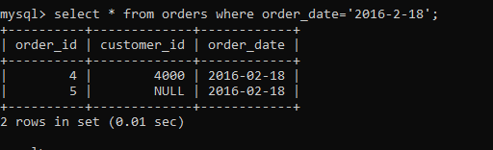

6.find orderid and customerid for orders place on feb 2016

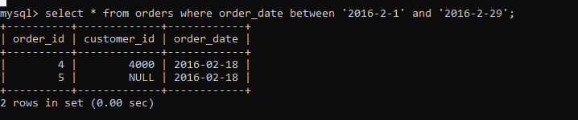

7.find all customers with name 'Reynolds', or Anderson

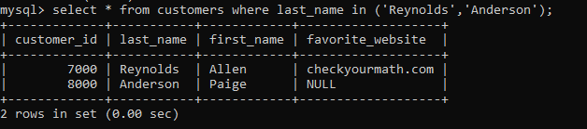

8. find all customers for whome favorite_website is not given

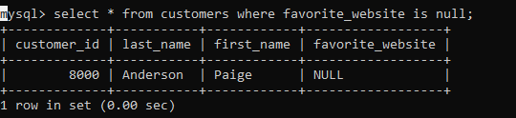

9. find all customers for whome favorite_website is given

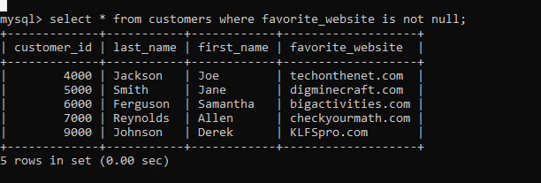

**LAB-2**

**Date and Time functions**

1. Write a query to display the first day of the month (in datetime format) three

months before the current month.

Sample current date : 2014-09-03

Expected result : 2014-06-01

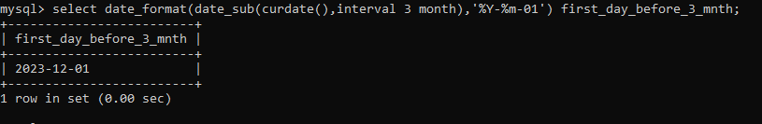

2. Write a query to display the last day of the month (in datetime format) three

months before the current month.

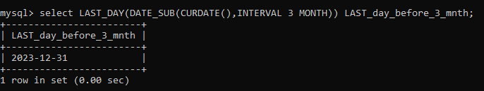

3. Write a query to get the distinct Mondays from hiredate in emp tables.

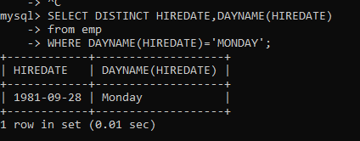

4. Write a query to get the first day of the current year.

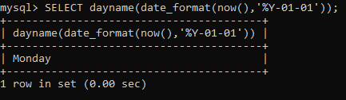

5. Write a query to get the last day of the current year.

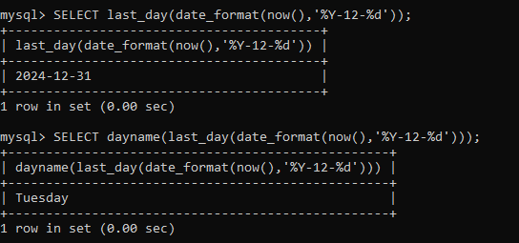

6. Write a query to calculate your age in year.

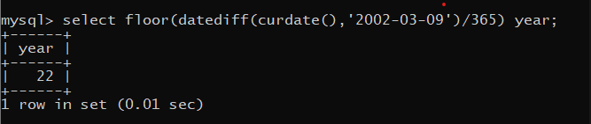

7. Write a query to get the current date in the following format.

Sample date : 04-sep-2014

Output : September 4, 2014

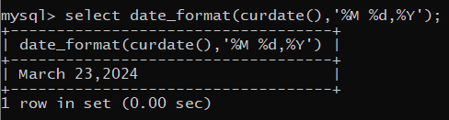

8. Write a query to get the current date in Thursday September 2014 format.

Thursday September 2014

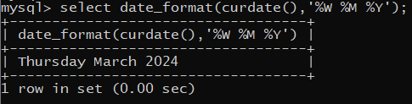

1. Write a query to extract the year from the current date.

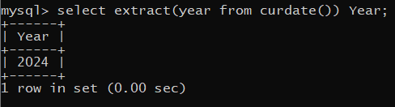

10. Write a query to get the first name and hire date from employees table

where hire date between '1987-06-01' and '1987-07-30'



11. Write a query to display the current date in the following format.

Sample output: Thursday 4th September 2014 00:00:00

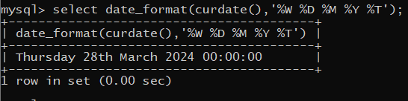

12. Write a query to display the current date in the following format.

Sample output: 05/09/2014

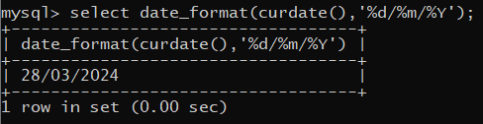

13. Write a query to display the current date in the following format.

Sample output: 12:00 AM Sep 5, 2014

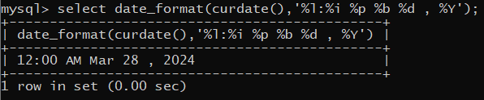

1. Write a query to get the employees who joined in the month of June.

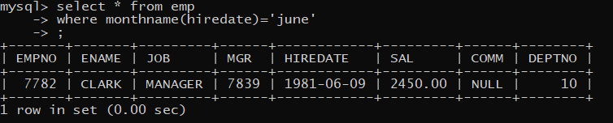

15. Write a query to get the years in which more than 10 employees joined.

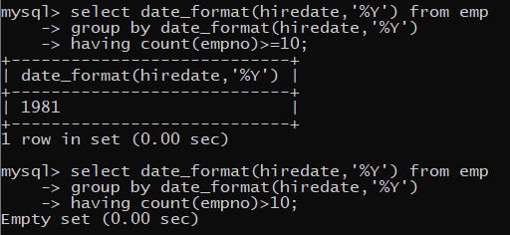

16. Write a query to get first name of employees who joined in 1987.

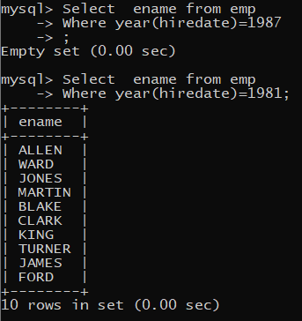

17. Write a query to get employees whose experience is more than 5 years.

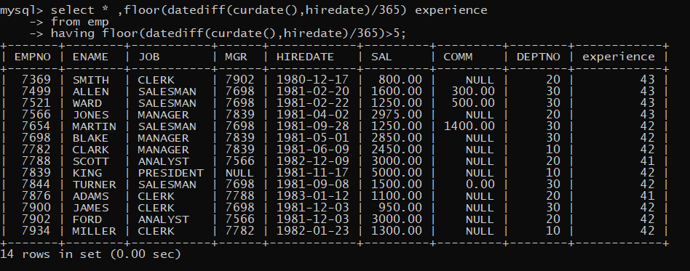

18. Write a query to get employee ID, last name, and date of first salary of the

employees.

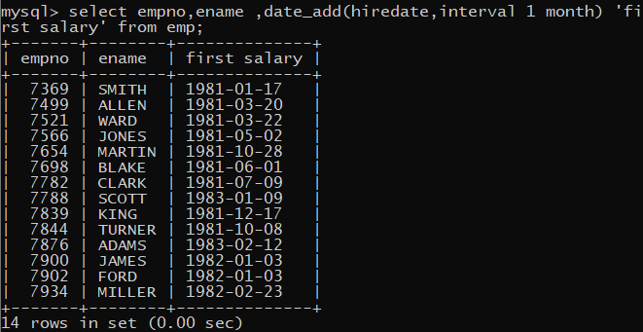

19. Write a query to get first name, hire date and experience of the

employees.

Sample table: employees

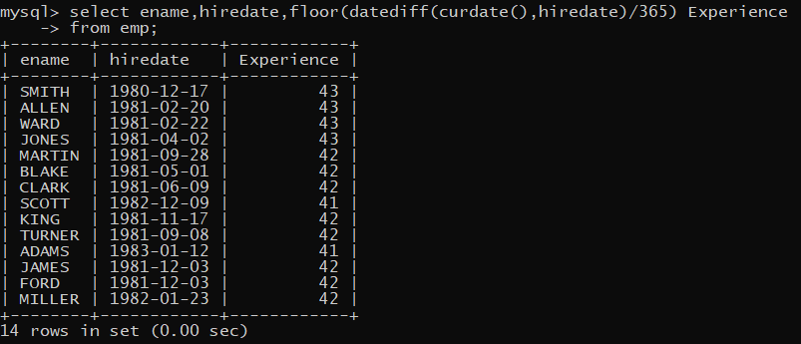

20. Write a query to get the department ID, year, and number of employees

joined.

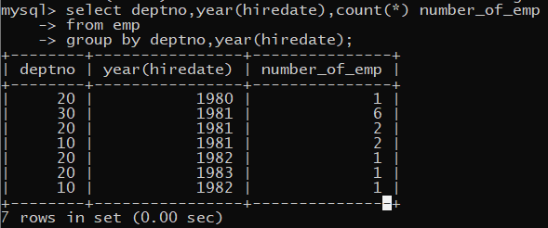

L**AB-3**

**Write SQL statement for the following**

1. To find all managers with salary >1500

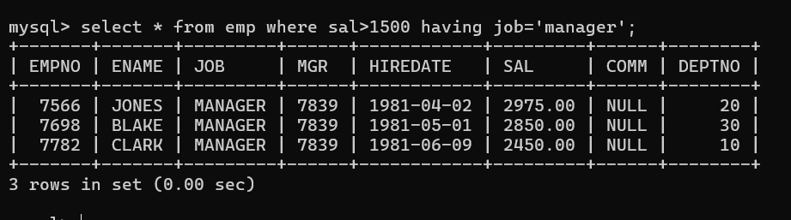

1. list all employees with sal >1200 and < 2000

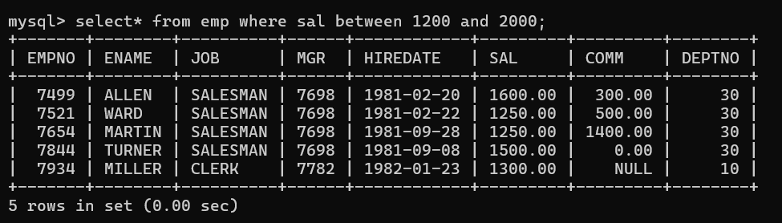

2. list all employees with sal is 1600 or sal is 800 or sal is 1900

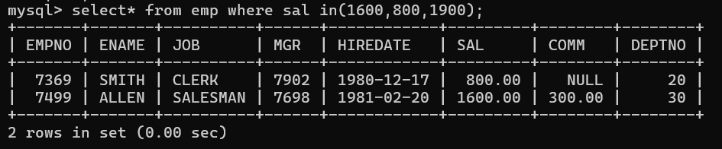

1. list all employees with R at second last position in name

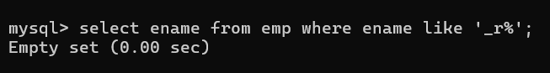

1. List all employees with name starts with A and ends with N

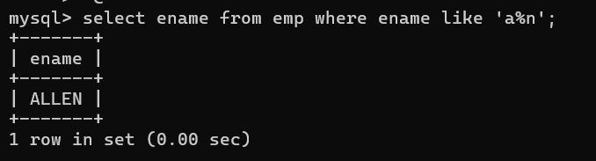

**Q2. Solve following**

1. list all employees with salary > 1250 and dept no=30

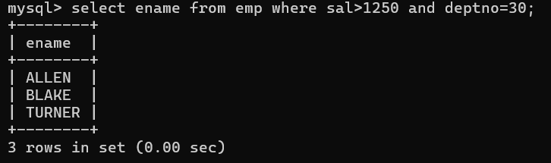

1. list all employees with salary >=1250 and <= 3000

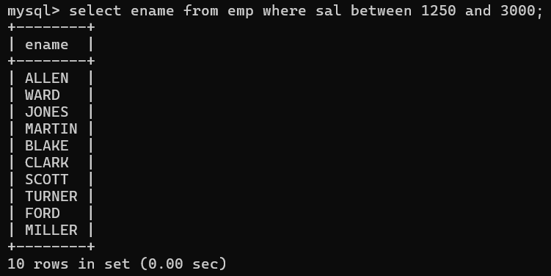

1. list all employees with salary >1250 and < 3000

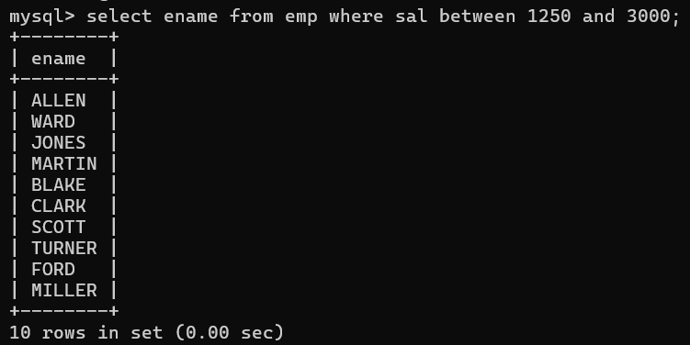

1. list all employees with salary either equal to 3000 or 1250 or 2500

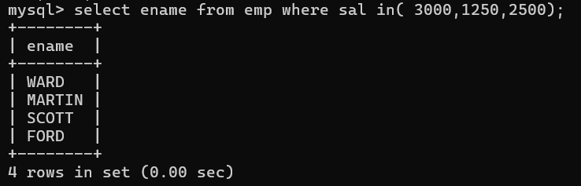

1. list all employee with name=SMITH

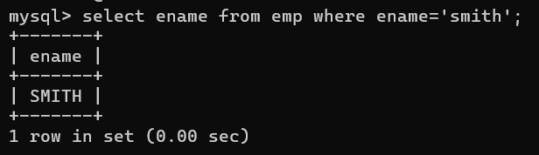

1. list all employees with name starting with S

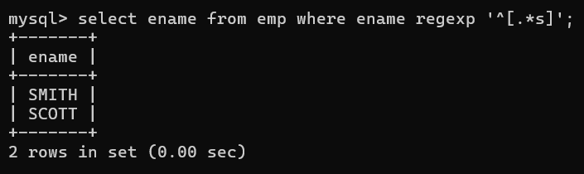

1. list all employees with name ending with S

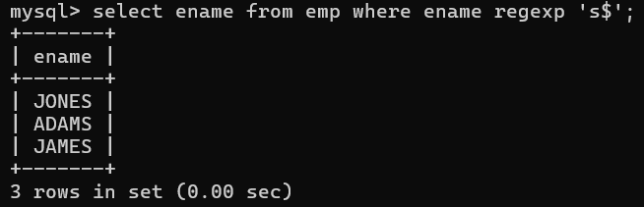

1. list all employees with name contains I at 2nd position

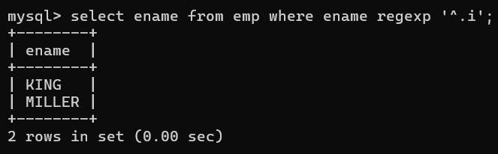

1. list all employees with name starts with A ends with N and somewhere in between L is there

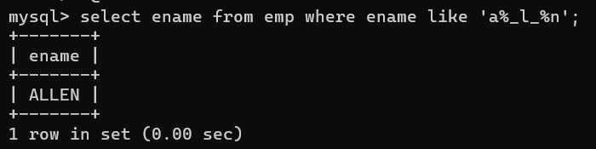

1. list all employees with name starts with A and B at 3 rd position and P at second last position

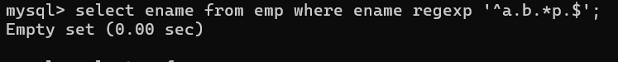

1. List all employees with name starts with either A or starts with S or starts with W

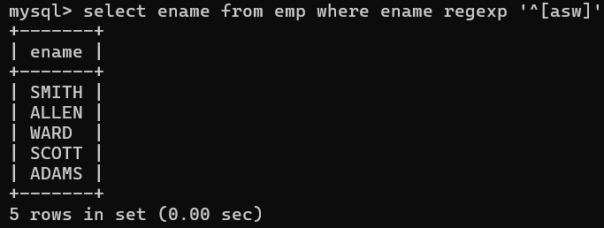

**practice Aggregate functions**

1. find max sal and min sal for each job

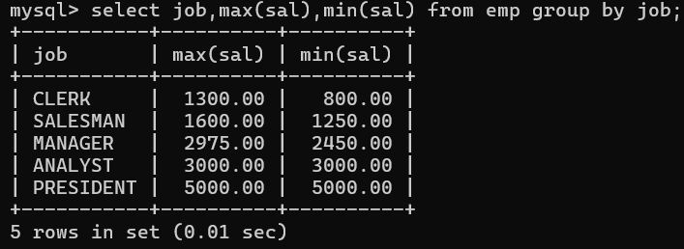

1. find how many employess have not received commission

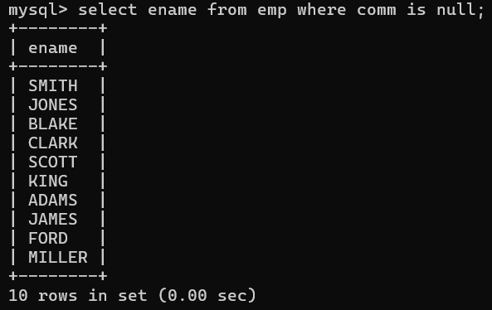

1. find sum of sal of all employees working in dept no 10

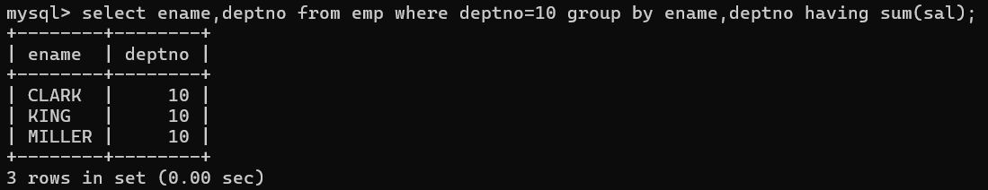

1. find maximum salary,average sal for each job in every department

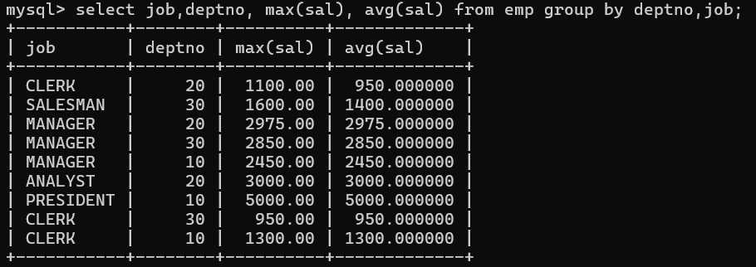

1. find max salary for every department if deptno is > 15 and arrange data in deptno order.

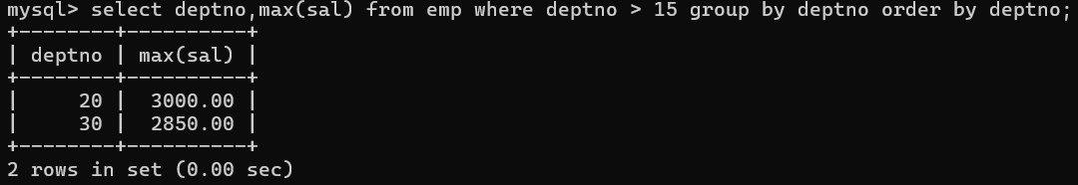

1. find sum salary for every department if sum is > 3000

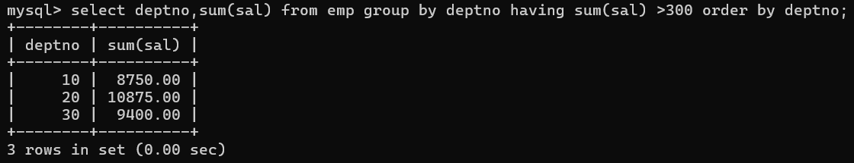

1. list all department which has minimum 5 employees

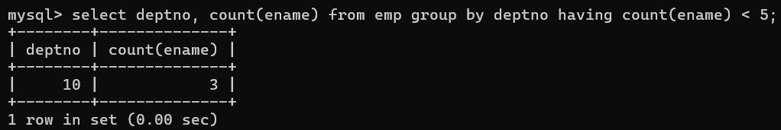

1. count how many employees earn salary more than 2000 in each job

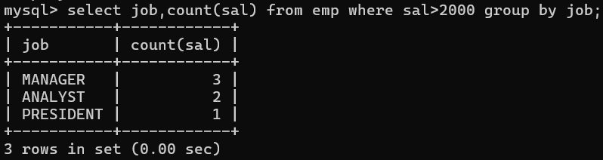

1. list all enames and jobs in small case letter

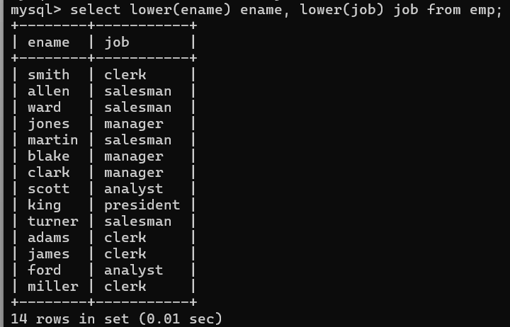

21. list all names and jobs so that the length of name should be 15 if it is smaller then add spaces

to left

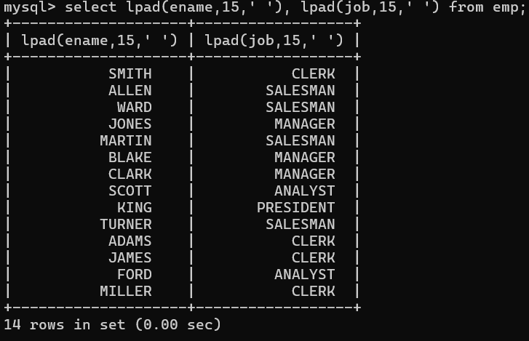

1. display min sal,max sal, average sal for all employees working under same manager



23. find sum of total earnings(sal+comm), average of sal+comm,

for all employees who earn sal > 2000 and work in either dept no 10 or 20

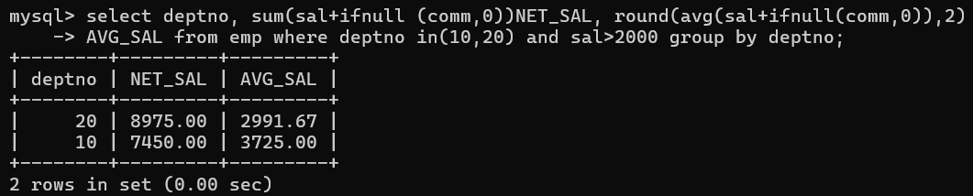

24. list all employees who joined in Aug 1980 and salary is >1500 and < 2500



25. list all employees joined in either aug or may or dec

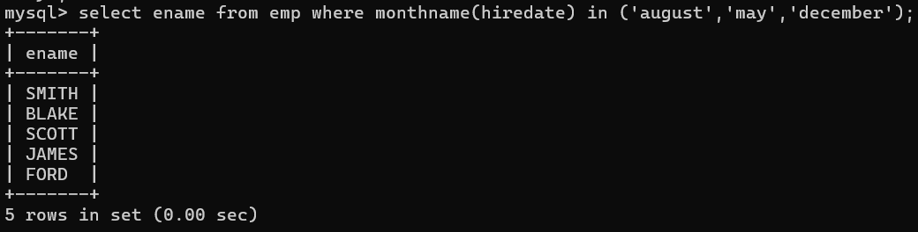

26. display name and hiredate in dd/mm/yy format for all employees whose job is clerk and they

earn some commission

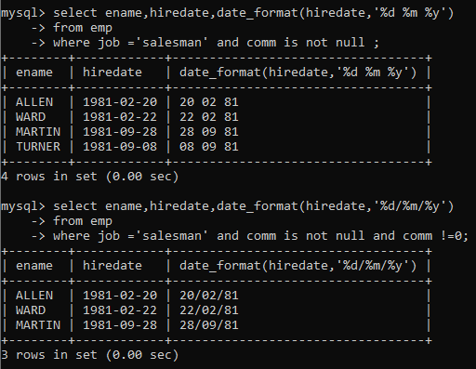

27. list empcode,empno,name and job for each employee. (note :empcode is 3 to 5 characters

from name and last 2 characters of job)

28. display thousand separator and $ symbol for commission if it is null then display it as 0 for all

employees whose name starts with A and ends with N

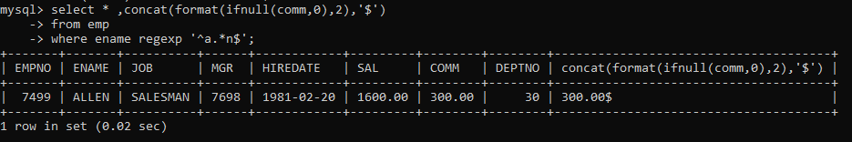

29. Display empid,name,sal,comm,remark Remark should base on following conditions

comm >= 600 "excellent Keep it up"

if it < 600 or not null "good"

otherwise "Need improvement"

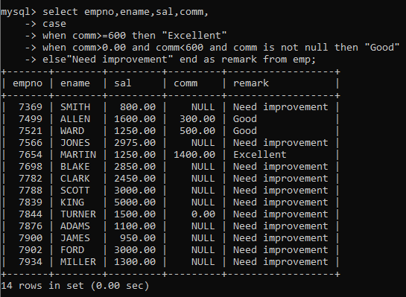

30. Display empid, name, deptno and department name by using following conditions.

dept 10 then "Hr"

if 20 then "Admin"

if 30 then "accounts"

otherwise purchase

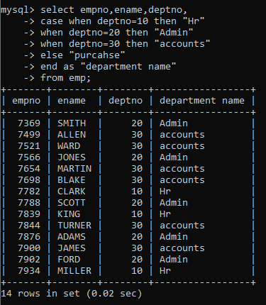

**Topic ----------------- create Table, DML , subquery and joins**

31. Practice creating following tables

MySQL syntax:

create table mydept_DBDA

(

deptid int primary key,

dname varchar(20) not null unique,

dloc varchar(20)

)

Oracle syntax:

create table mydept_DBDA

(

deptid number primary key,

dname varchar2(20) not null unique,

dloc varchar2(20)

)

insert into mydept_DBDA values(30,'Purchase','Mumbai');

MySql syntax:

create table myemployee

(

empno int primary key,

fname varchar(15) not null,

mname varchar(15),

lname varchar(15) not null,

sal float(9,2) check(sal >=1000),

doj date,

passportnum varchar(15) unique,

deptno int,

constraint fk_deptno foreign key(deptno) references mydept_DBDA(deptid) on

delete set null

on update cascade

)

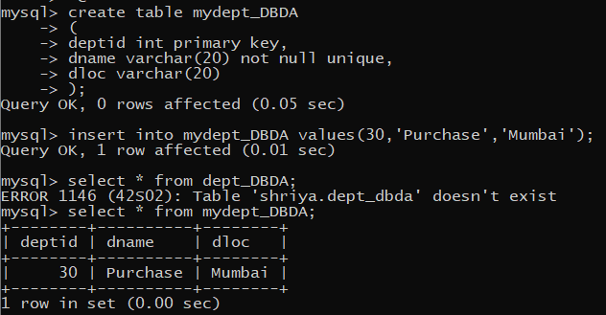

32. Create following tables Student, Course

Student (sid,sname) ---------------- sid ---primary key

Course(cid,cname)-------------- cid ---primary key

Marks(studid,courseid,marks)

Sample data for marks table

studid,courseid,marks

1 1 99

1 3 98

2 1 95

2 2 97

create table marks(

studid number,

courseid number,

marks number,

constraint pk primary key(studid,courseid),

constraint fk_sid foreign key (studid) references student(sid) on delete cascade,

constraint fk_cid foreign key (courseid) references course(cid)

)

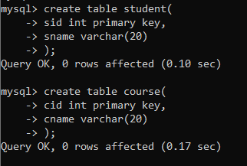

33. Create empty table emp10 with table structure same as emp table.

create table emp10 as

(

select *

from emp

where 1=2;

)

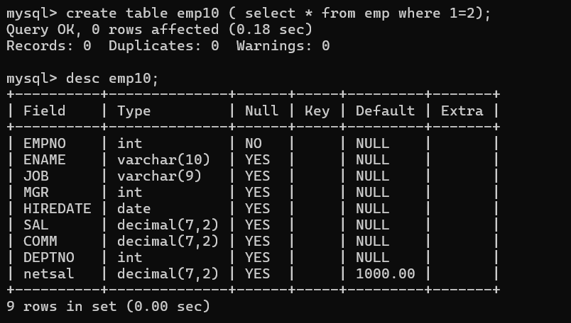

34. Solve following using alter table

add primary key constraint on emp,dept,salgrade

emp ----→ empno

dept---→ deptno

salgrade---→ grade

add foreign key constarint in emp

deptno --->> dept(deptno)

add new column in emp table netsal with constraint default 1000

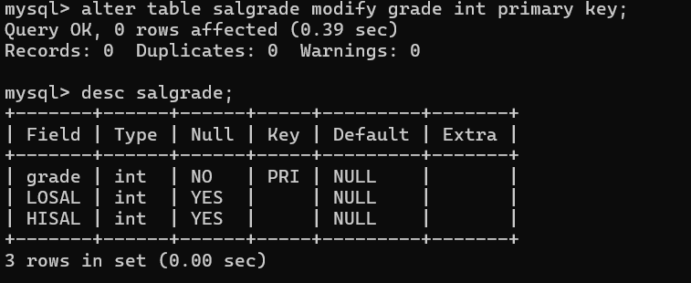

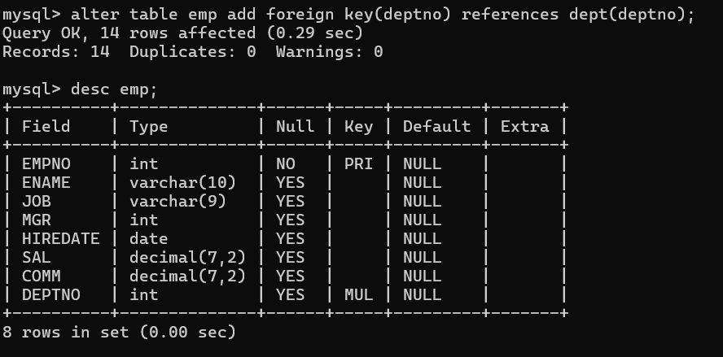

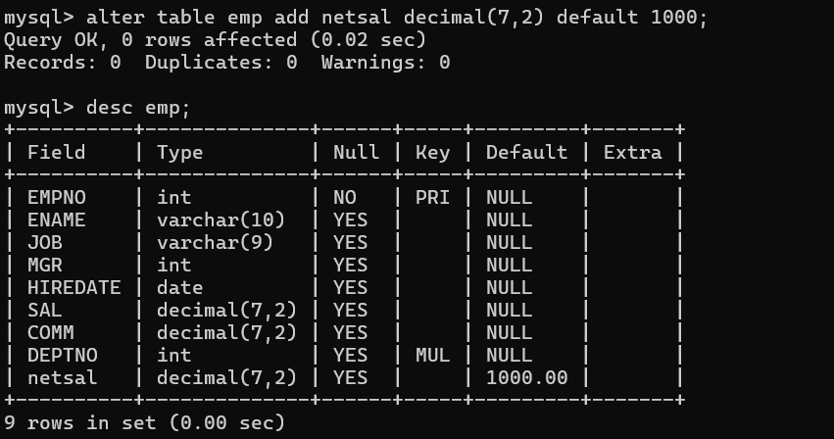

35. Update employee sal ---- increase sal of each employee by 15 % sal +comm, change the job to

manager and mgr to 7777 for all employees in deptno 10.

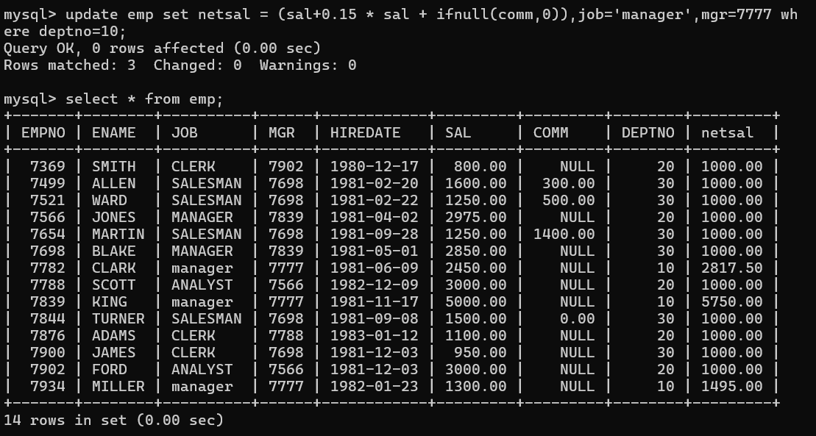

36. change job of smith to senior clerk

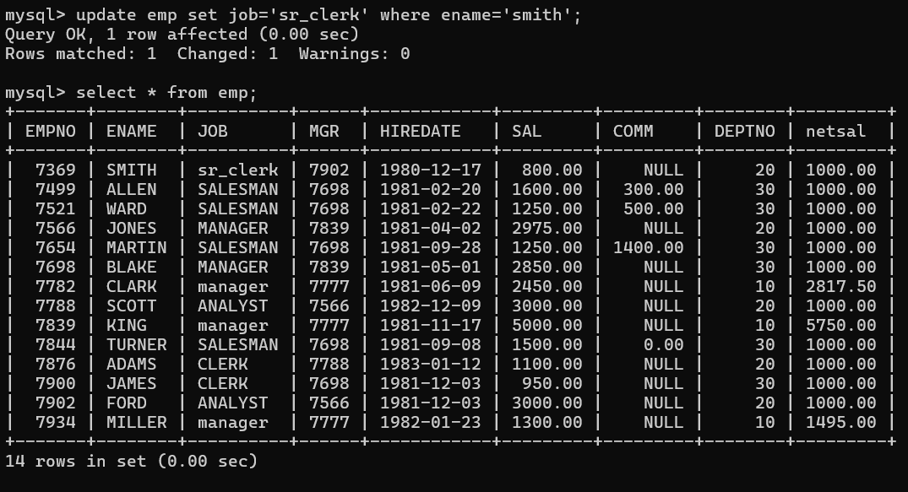

37. increase salary of all employees by 15% if they are earning some commission

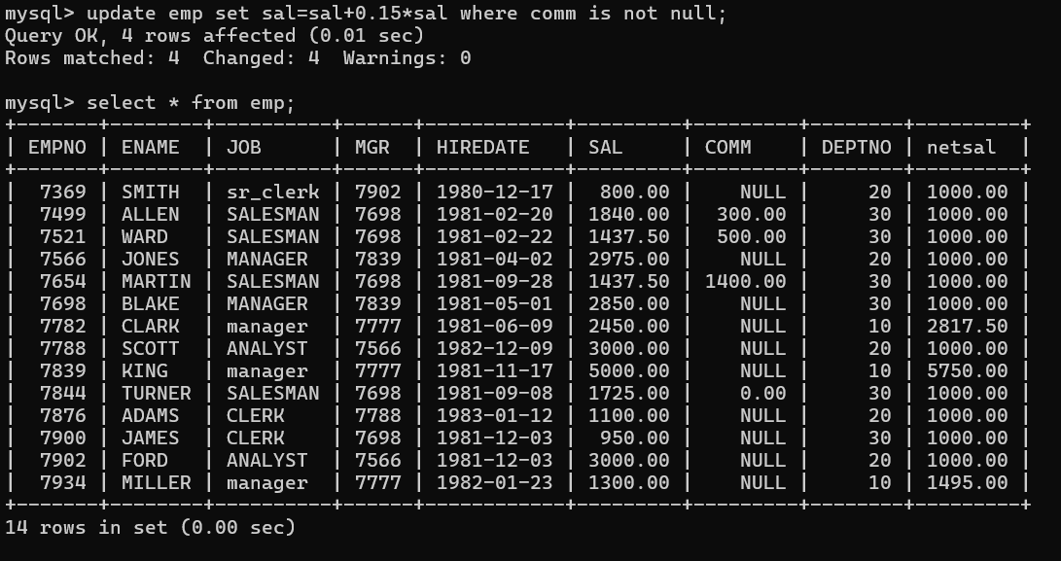

38. list all employees with sal>smith's sal

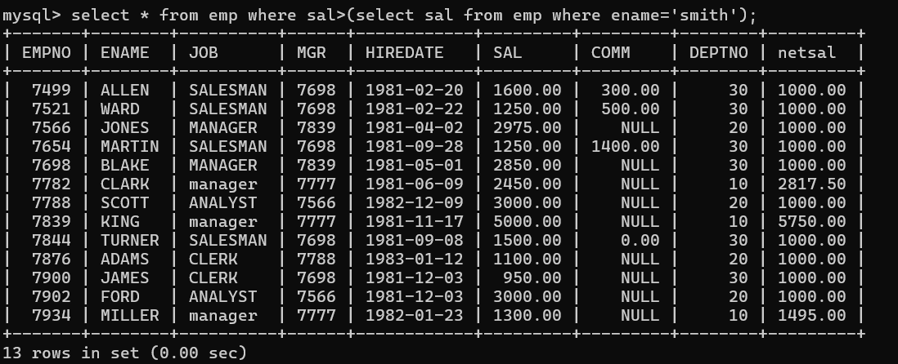

39. list all employees who are working in smith's department

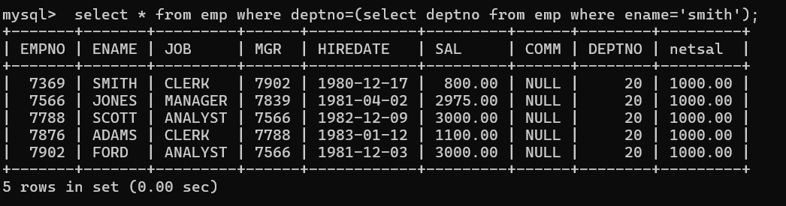

40. list all employees with sal < rajan's sal and salary > revati's sal

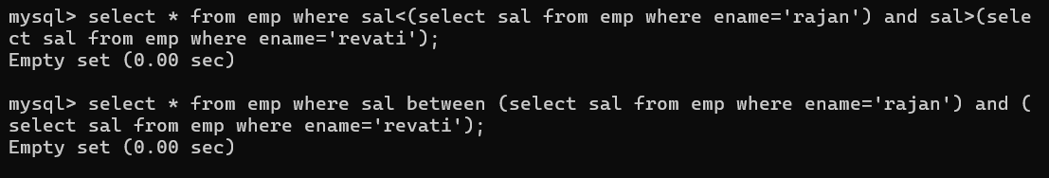

41. delete all employees working in alan's department



42. change salary of Alan to the salary of Miller.



43. change salary of all emplees who working in Wall's department to the salary of Miller.

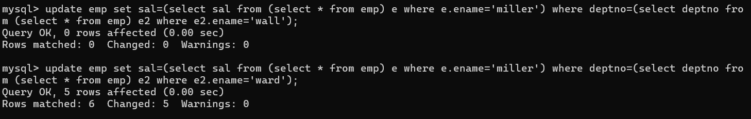

44. list all employees with salary > either Smith's salary or alan's sal

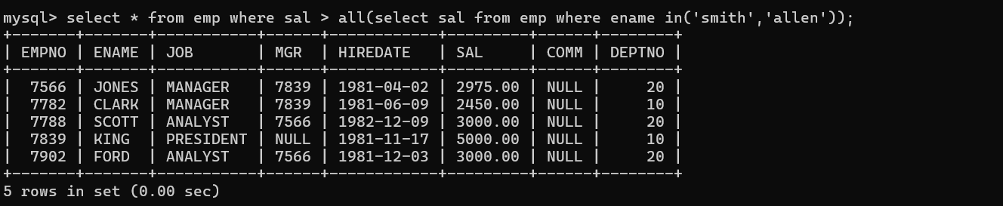

45. list all employees who earn more than average sal of dept 10

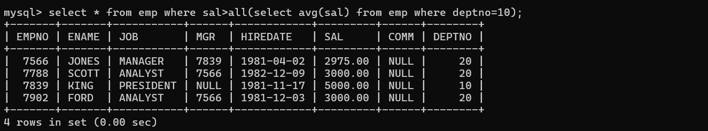

46. list all employees who earn more than average sal of Alan's department



47. list all employees who are working in purchase department



48. list all employees who earn more than average salary of their own department

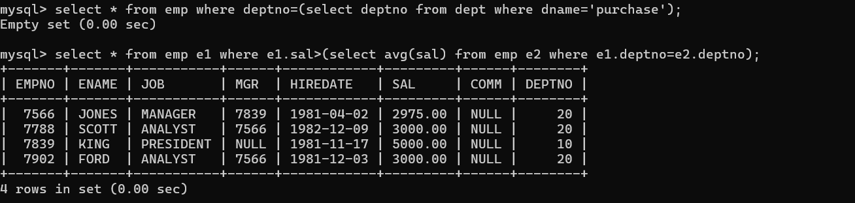

49. list all employees who earn sal < than their managers salary

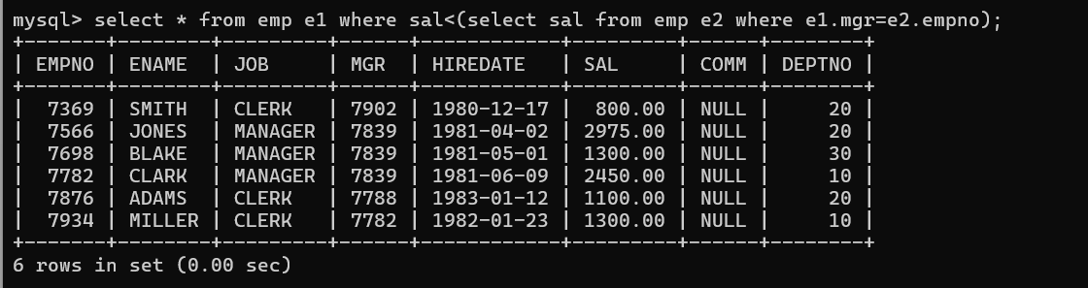

50. list all employees who are earning more than average salary of their job

51. display employee name and department

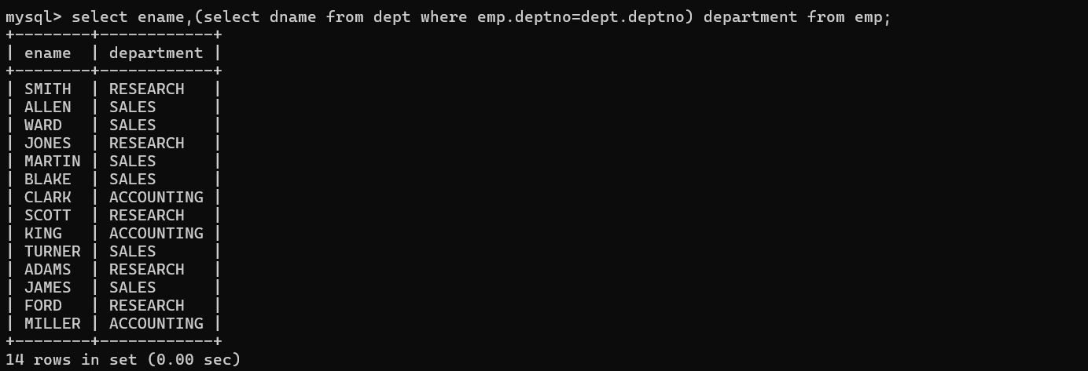

52. display empno,name,department name and grade (use emp,dept and salgrade table)

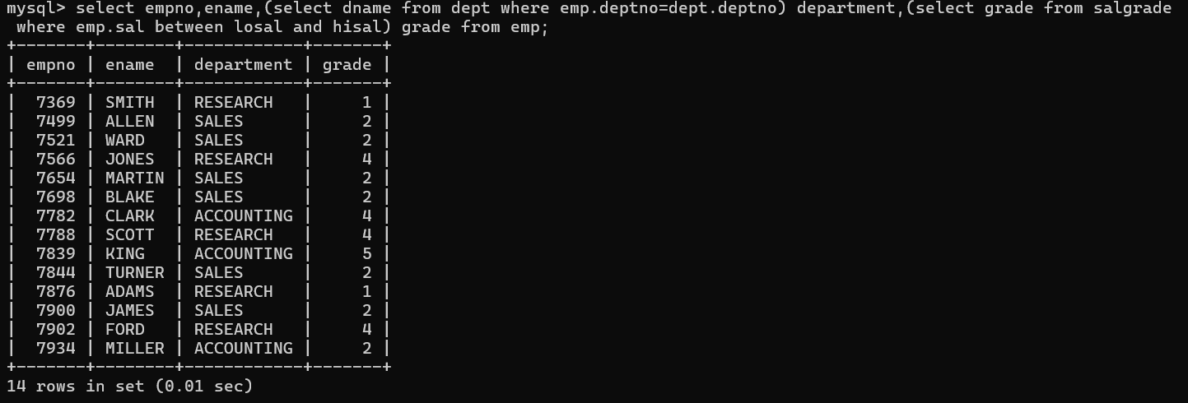

53. list all employees number,name, mgrno and manager name

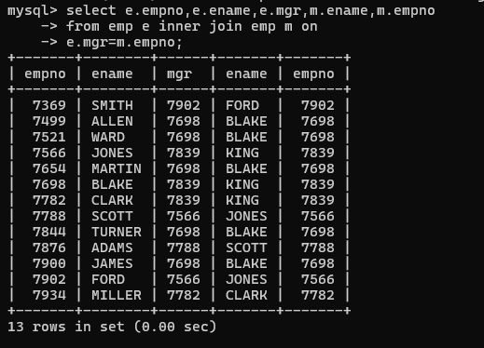

54. create following tables and solve following questions(primary keys are marked in yellow)

foreign keys are marked in green

product(pid,pname,price,qty,cid,sid)

salesman (sid,sname,address)

category(cid,cnam,descritpion)

1. list all product name,their category name and name of a person, who sold that product

1. list all product name and salesman name for all salesman who stays in pune

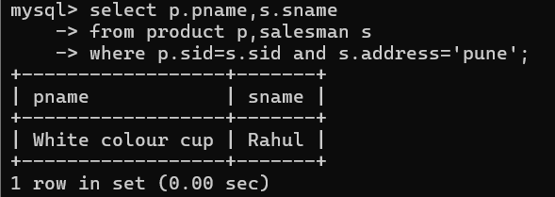

1. list all product name and category name

55. create following tables and solve following questions(primary keys are marked in yellow)

foreign keys are marked in green

faculty(fid,fname,sp.skill1,sp.skill2)

courses(cid,cname,rid,fid)

room(roomid,rname,rloc)

faculty

fid fname spskill1 spskill2

10 kjzhcjhz a b

11 sdd x z

12 lksjk a x

13 ksdjlkj a b

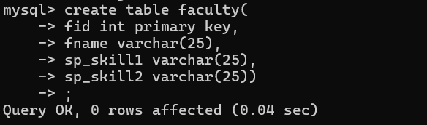

courses

cid cname rid fid

121 DBDA 100 10

131 DAC 101

141 DTISS

151 DIOT 105 12

Room

roomid rname rloc

100 jasmin 1st floor

101 Rose 2nd floor

105 Lotus 1st floor

103 Mogra 1st floor

1. list all courses for which no room is assigned and all rooms for which are

Available

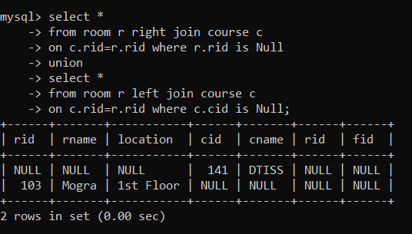

2. list all faculties who are not allocated to any course and rooms which are not

allocated to any course

3. list all rooms which are allocated or not allocated to any courses

1. list all rooms which are not allocated to any courses

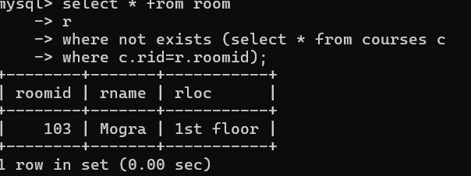

5. display courses and faculty assigned to those courses whose special skill is

Database

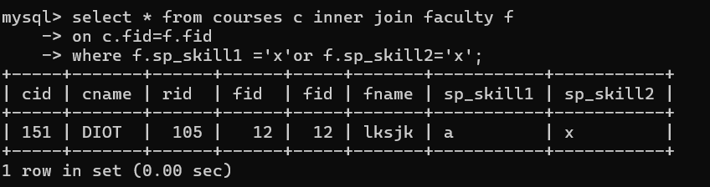

6. display time table --- it should contain course details , faculty and room

Details

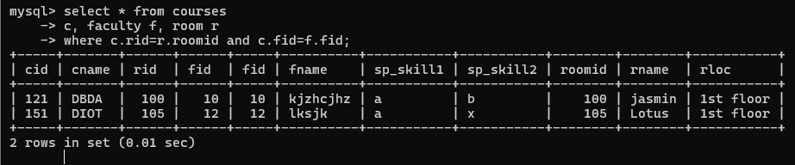

56. create following tables with given constraints

product---- qty >0, default 20.00,pname not null and unique

prodid pname qty price catid sid

123 lays 30 30.00 1 12

111 pepsi 40 50.00 4 11

134 nachos 50 50.00 1 12

124 dairy milk 40 60.00 2 14

124 pringles 40 60.00 1 14

saleman ----- sname -----not null

sid sname city

11 Rahul Pune

12 Kirti Mumbai

13 Prasad Nashik

14 Arnav Amaravati

category ---- cname unique and not null

cid cname description

1 chips very crunchy

2 chocolate very chocolaty

3 snacks yummy

4 cold drinks thanda thanda cool cool

1. List all products with category chips

1. display all products sold by kirti

1. display all salesman who do not sold any product

1. display all category for which no product is there

1. display all products with no category assigned

1. list all salesman who stays in city with name starts with P or N

1. add new column in salesman table by name credit limit

**LAB-4**

**Solve the following**

1. write a procedure to insert record into employee table.

the procedure should accept empno, ename, sal, job, hiredate as input parameter

write insert statement inside procedure insert_rec to add one record into table

create procedure insert_rec(peno int,pnm varchar(20),psal decimal(9,2),pjob varchar(20),phiredate date)

begin

insert into emp(empno,ename,sal,job,hiredate) values(peno,pnm,psal,pjob,phiredate)

end//

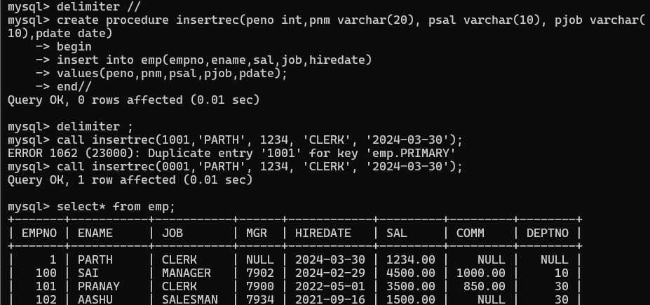

2. write a procedure to delete record from employee table.

the procedure should accept empno as input parameter.

write delete statement inside procedure delete_emp to delete one record from emp table

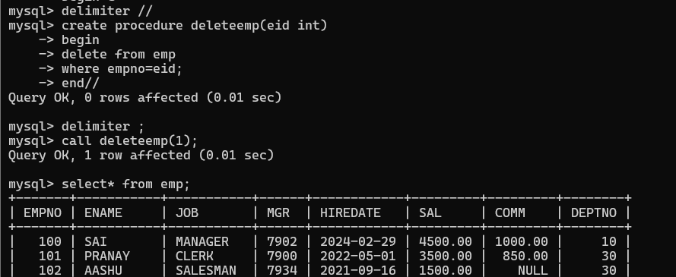

1. write a procedure to display empno,ename,deptno,dname for all employees with sal > given salary. pass salary as a parameter to procedure

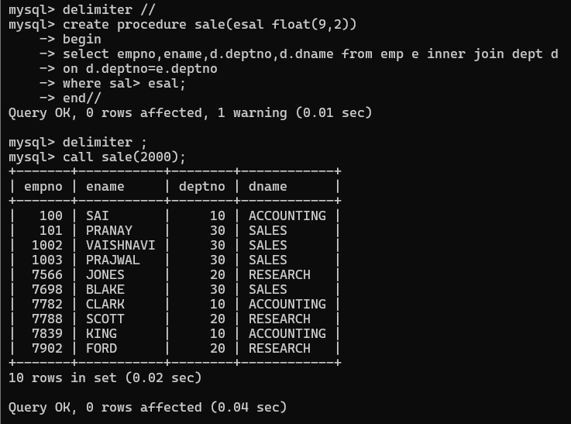

4. write a procedure to find min,max,avg of salary and number of employees in the given deptno.

deptno --→ in parameter

min,max,avg and count ---→ out type parameter

execute procedure and then display values min,max,avg and count

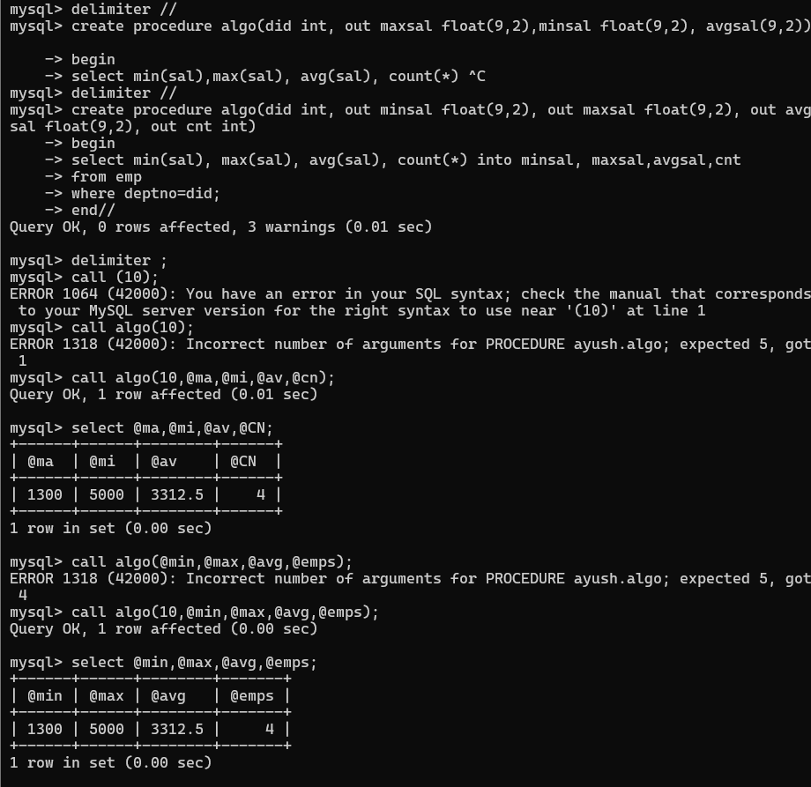

1. write a procedure to display all pid,pname,cid,cname and salesman name(use product,category and salesman table)

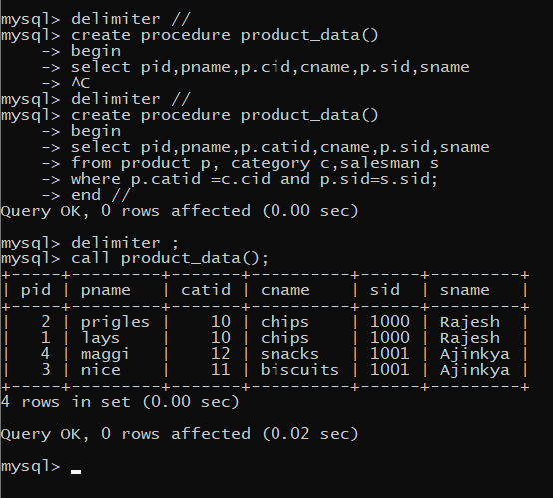

1. write a procedure to display all vehicles bought by a customer. pass cutome name as a parameter.(use vehicle,salesman,custome and relation table)

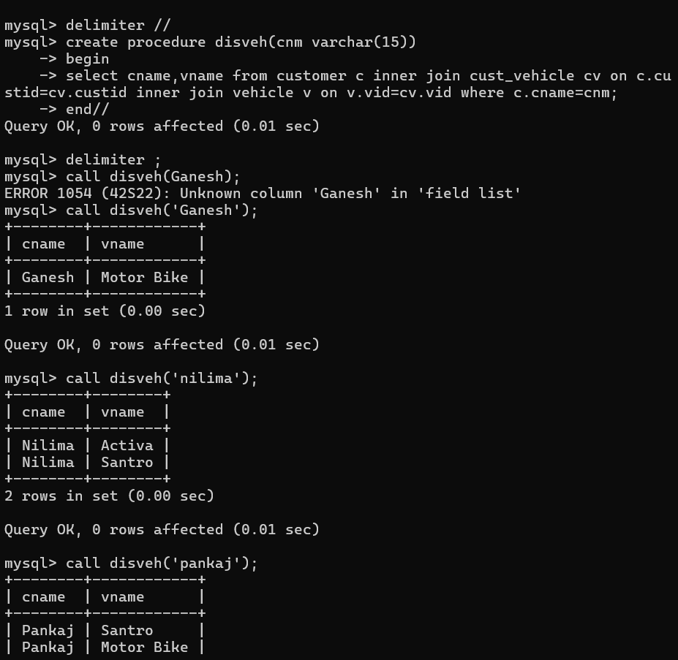

7. Write a procedure that displays the following information of all emp

Empno,Name,job,Salary,Status,deptno

Note: - Status will be (Greater, Lesser or Equal) respective to average salary of their own department. Display an error message Emp table is empty if there is no matching

record.

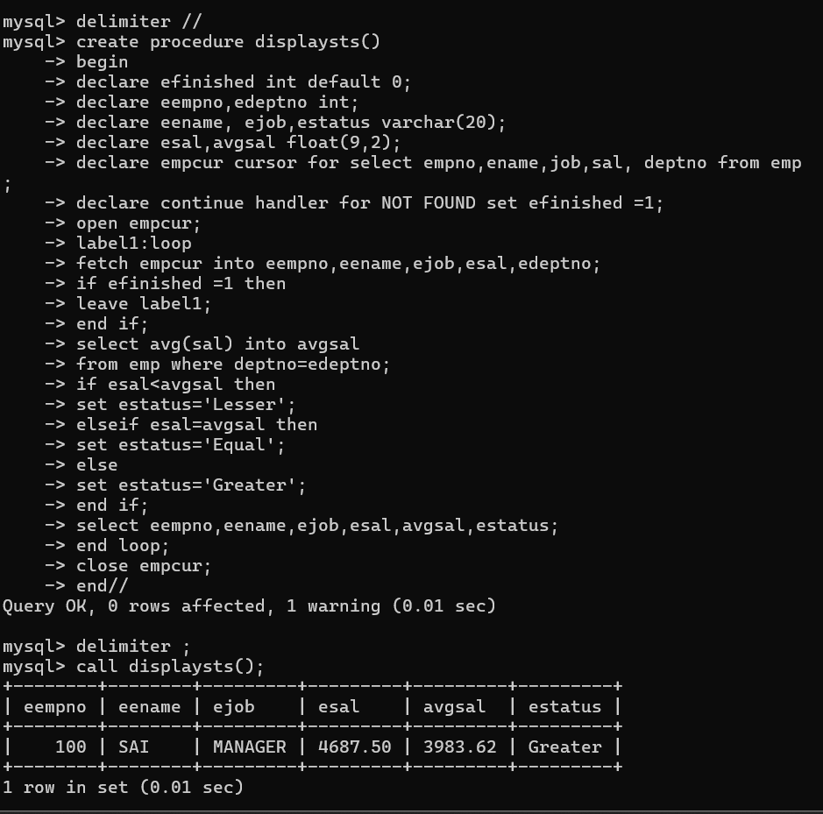

8. Write a procedure to update salary in emp table based on following rules.

Exp< =35 then no Update

Exp> 35 and <=38 then 20% of salary

Exp> 38 then 25% of salary

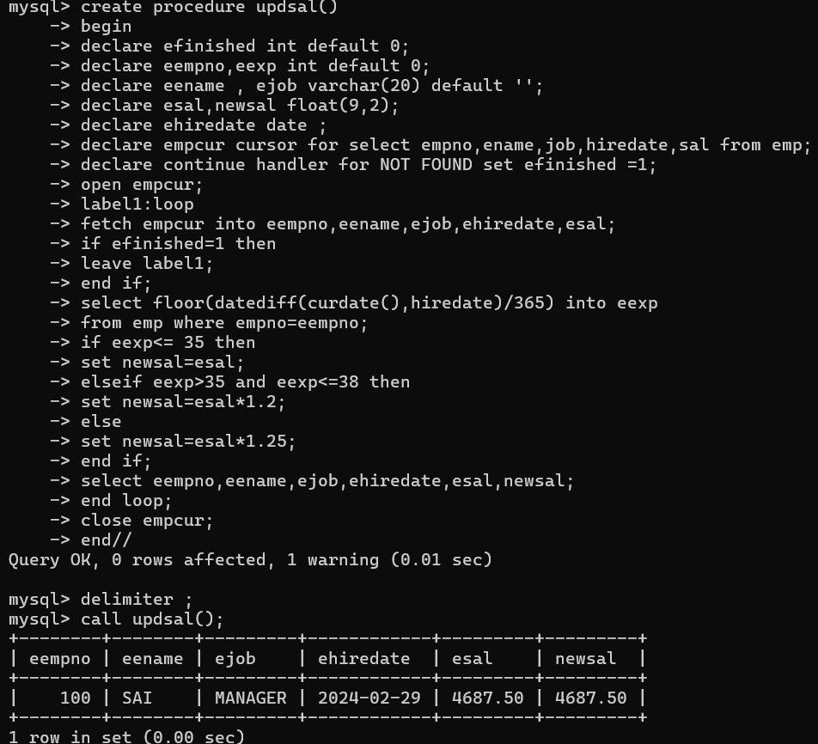

9. Write a procedure and a function.

Function: write a function to calculate number of years of experience of employee.(note: pass hiredate as a parameter)

Procedure: Capture the value returned by the above function to calculate the additional

allowance for the emp based on the experience.

10. Write a function to compute the following. Function should take sal and hiredate as i/p and return the cost to company.

DA = 15% Salary, HRA= 20% of Salary, TA= 8% of Salary.

Special Allowance will be decided based on the service in the company.

< 1 Year Nil

>=1 Year< 2 Year 10% of Salary

>=2 Year< 4 Year 20% of Salary

>4 Year 30% of Salary

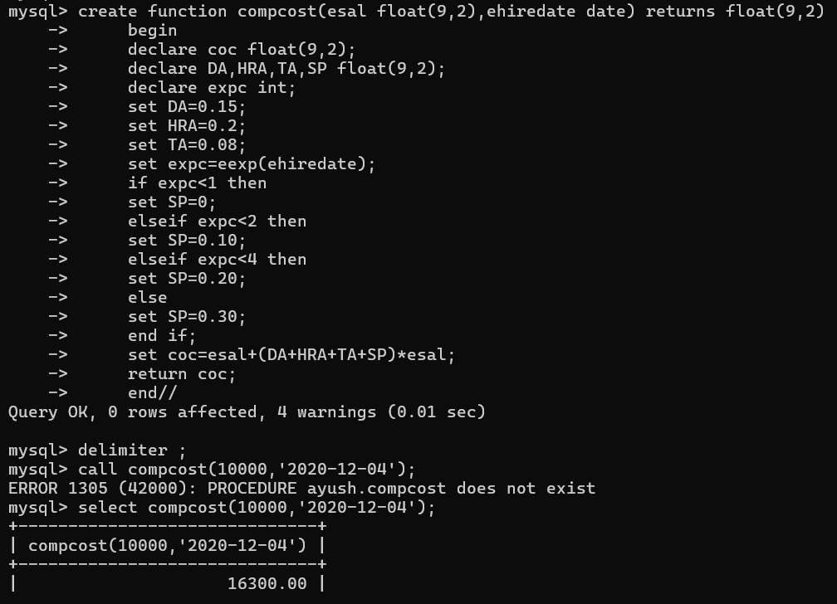

11. Write query to display empno,ename,sal,cost to company for all employees(note: use function written in question 10)

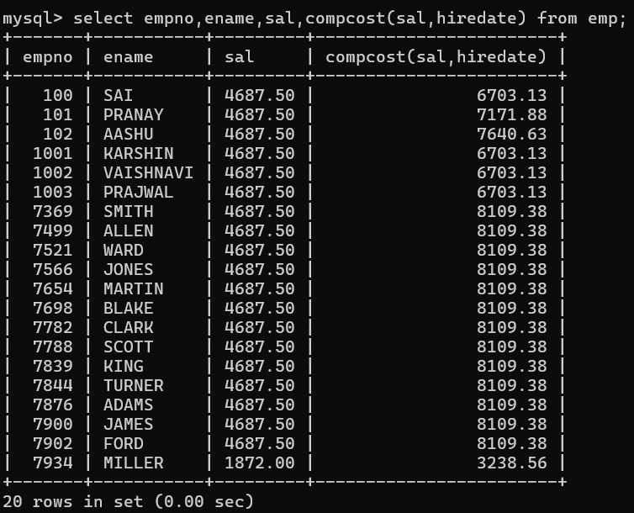

**Q2. Write trigger**

1. Write a tigger to store the old salary details in Emp _Back (Emp _Back has the same structure as emp table without any

constraint) table.

(note :create emp_back table before writing trigger)

----- to create emp_back table

create table emp_back(

empno int,

ename varchar(20),

oldsal decimal(9,2),

newsal decimal(9,2)

)

2. Write a trigger which add entry in audit table when user tries to insert or delete records in employee table store empno,name,username and date on which operation performed and which action is done insert or delete. in emp_audit table.

create table before writing trigger.

create table empaudit(

empno int;

ename varchar(20),

username varchar(20);

chdate date;

action varchar(20)

);

3. Create table vehicle_history. Write a trigger to store old vehicleprice and new vehicle price in history table before you update price in vehicle table

(note: use vehicle table).

create table vehicle_history(

vno int,

vname varchar(20),

oldprice decimal(9,2),

newprice decimal(9,2),

chdate date,

username varchar(20)

);

**LAB-5**

player (player_id, pname,speciality,date_of joining,num_matches,team_id)

team(team_id, tname,player_num)

matches(match_id, team1_id,team2_id,match_date,winner,man_of_the match)

simple query

1. display all players playerid, player name and experience

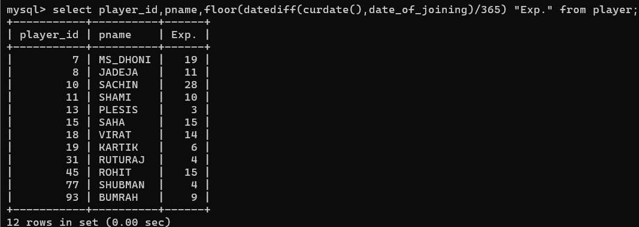

1. display all player with experience > 5 years

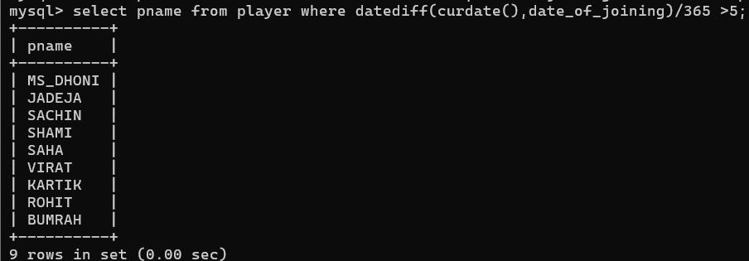

1. display all players joined in march month, any year

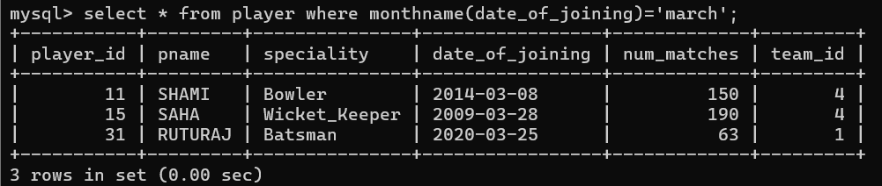

1. display all players joined in march 1995

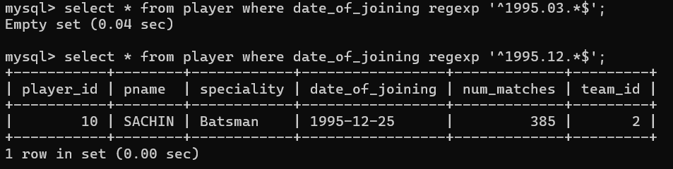

1. display all player with number of matches played are either 5 or 10 or 8

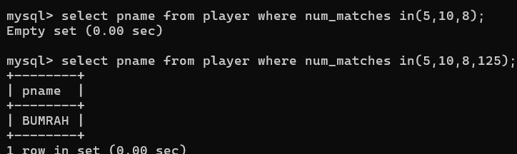

1. display all employees who are either batsman, bowler

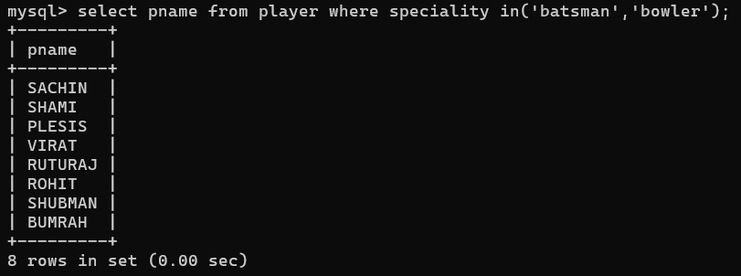

1. display all employees who joined in year 1995 or 1996 or 1997

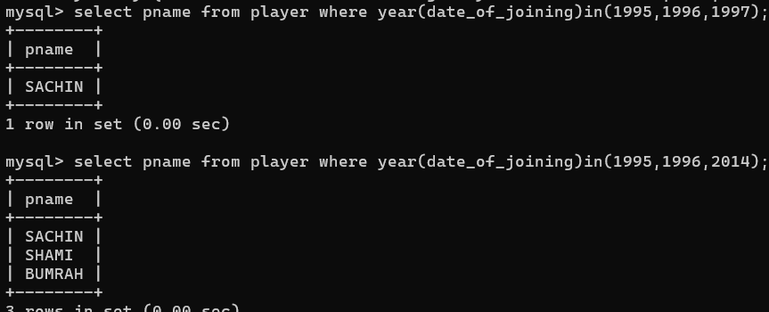

**Nested query**

1. list all player who plays in virat kohalis team

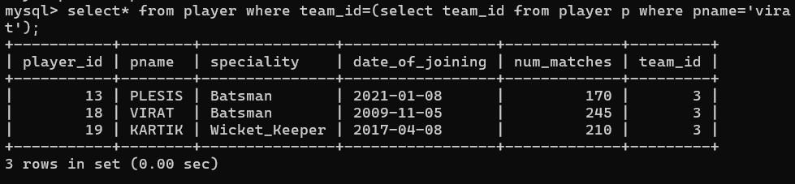

1. list all players who played matches in year 2024

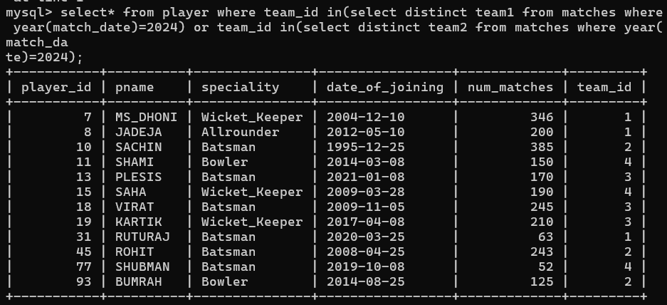

1. list all matches in which man of the match is from team1

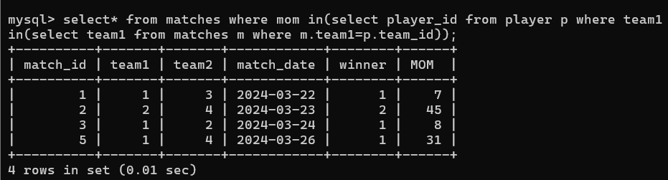

1. list all matches in which man of the match is from team1

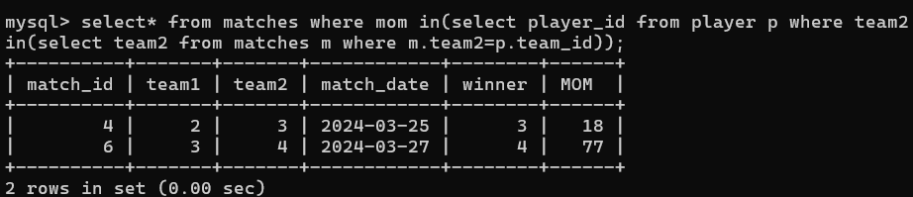

1. list all matches in which csk team win.

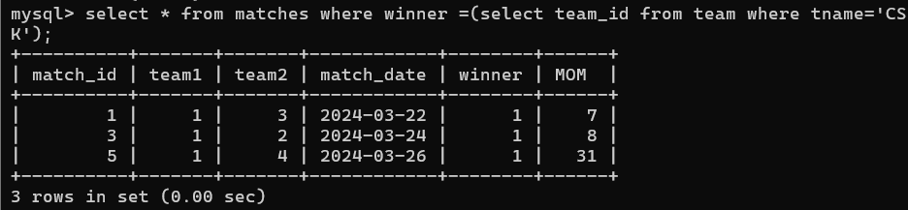

1. list all matches in which either csk or rcb team won the match

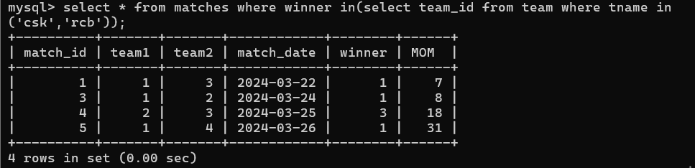

1. list all teams who one atleast one match

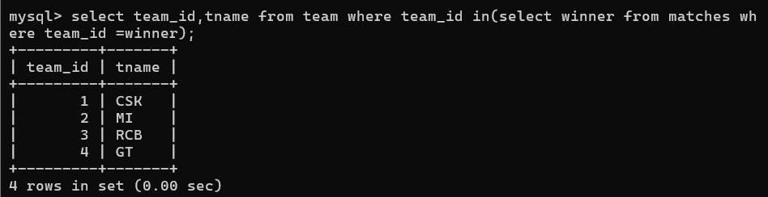

1. list all teams who does not played any match

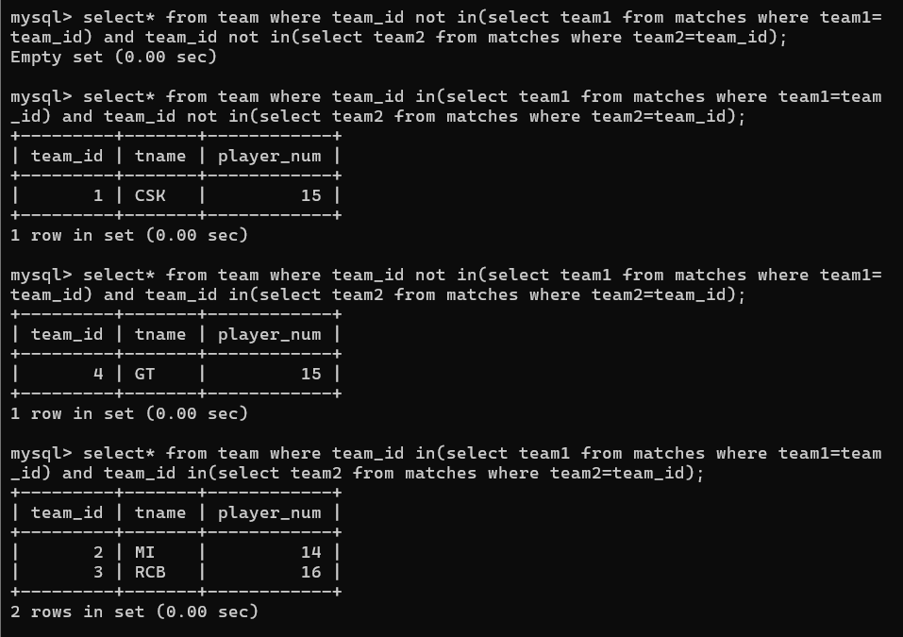

1. list all team name, in which no players are their

1. list all players who are in dhoni’s team

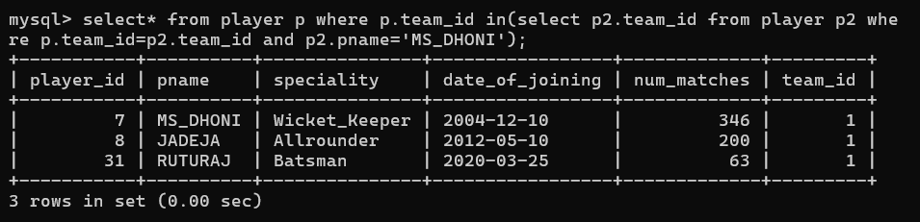

1. list all players who are in either dhoni’s or virat’s team

1. find all team names who one more than 3 matches

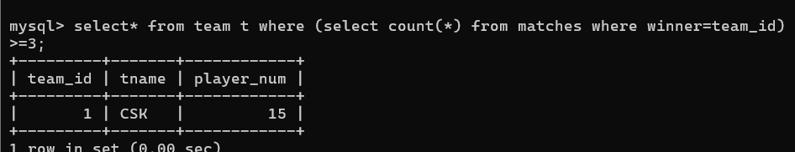

**MongoDB Assignments**

1. Write a MongoDB query to display all the documents in the collection restaurants  
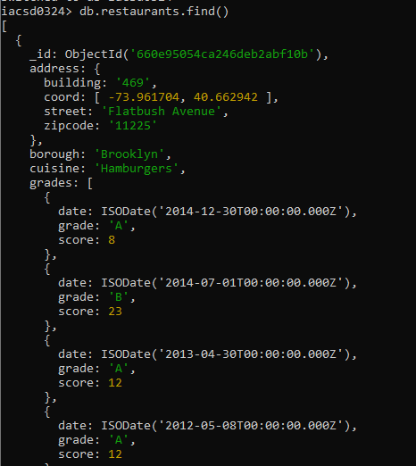

2. Write a MongoDB query to display the fields restaurant_id, name, borough and cuisine for

all the documents in the collection restaurant.

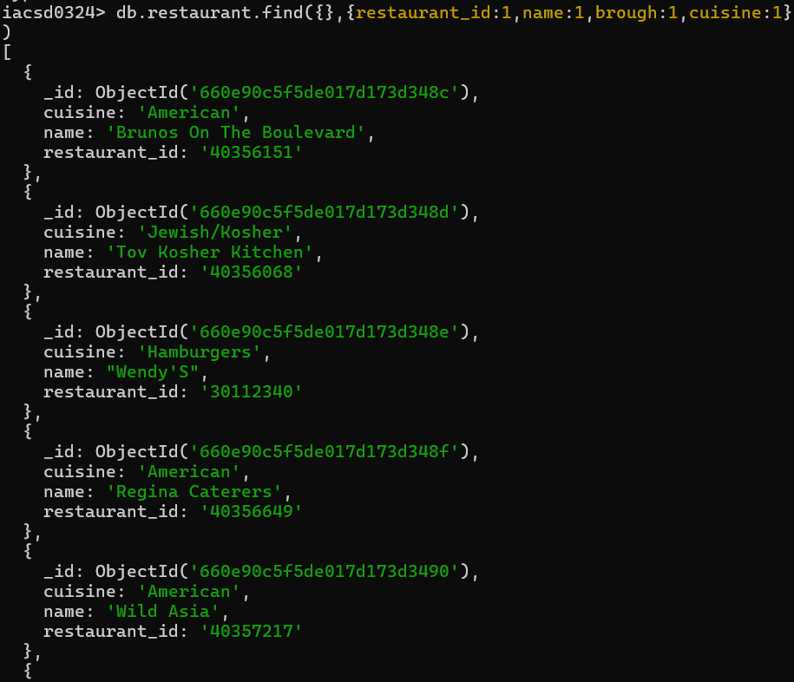

3. Write a MongoDB query to display the fields restaurant_id, name, borough and cuisine,

but exclude the field _id for all the documents in the collection restaurant.

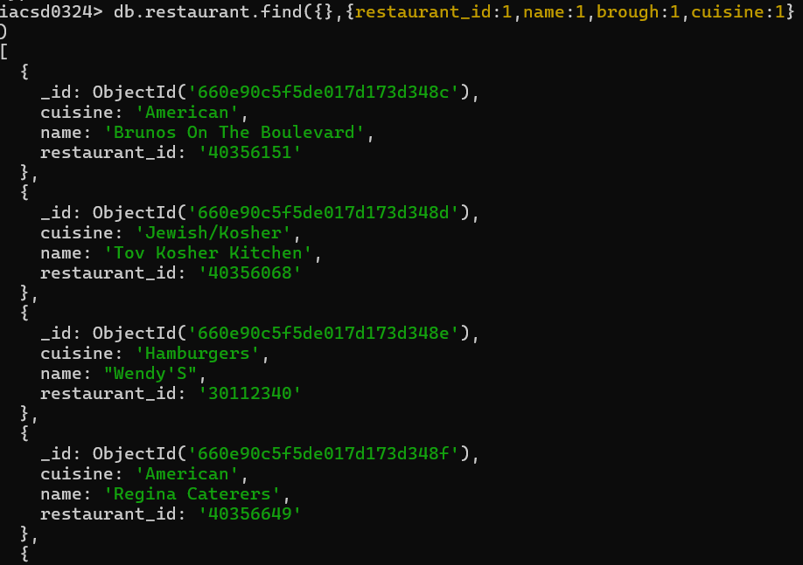

4. Write a MongoDB query to display the fields restaurant_id, name, borough and zip code,

but exclude the field _id for all the documents in the collection restaurant.

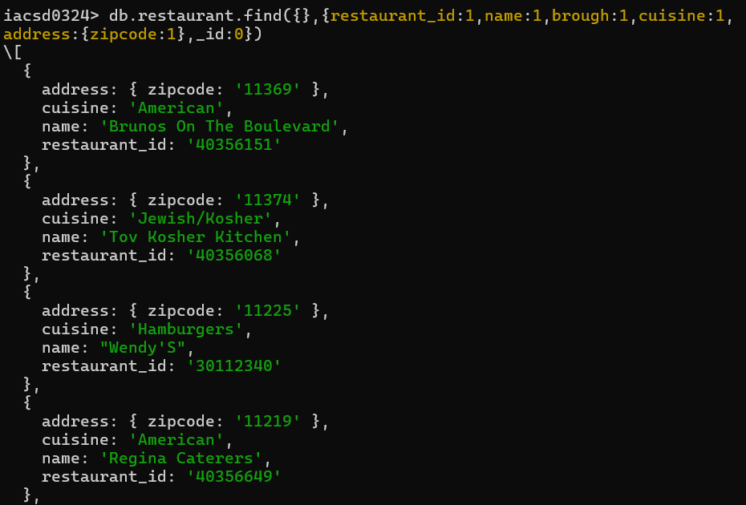

5. Write a MongoDB query to display all the restaurant which is in the borough Bronx

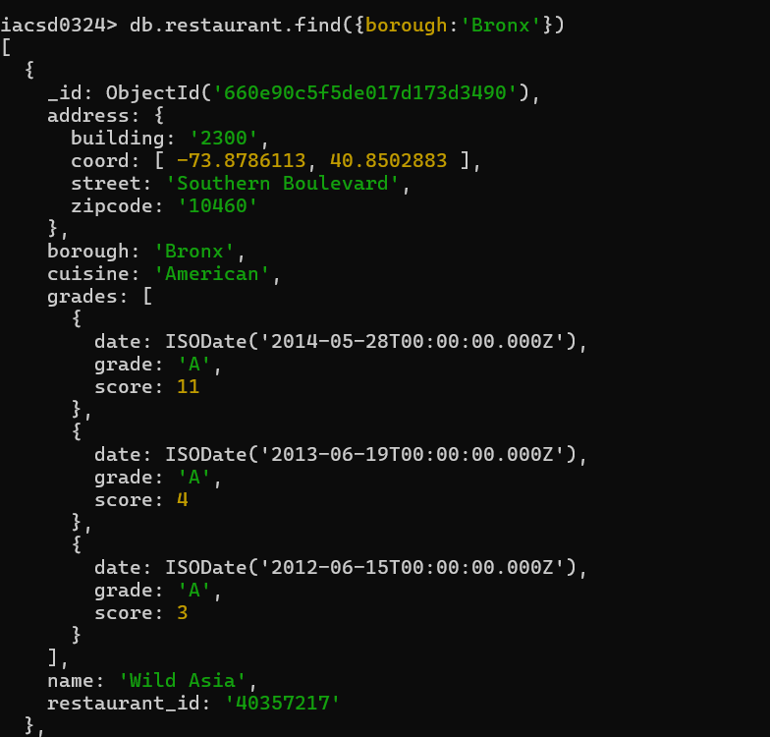

6. Write a MongoDB query to display the first 5 restaurant which is in the borough Bronx.

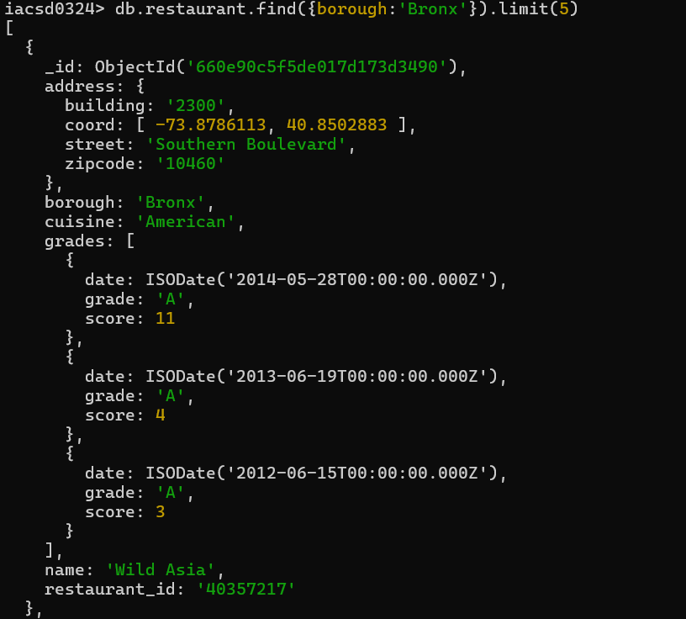

7.Write a MongoDB query to display the next 5 restaurants after skipping first 5 which are in

the borough Bronx.

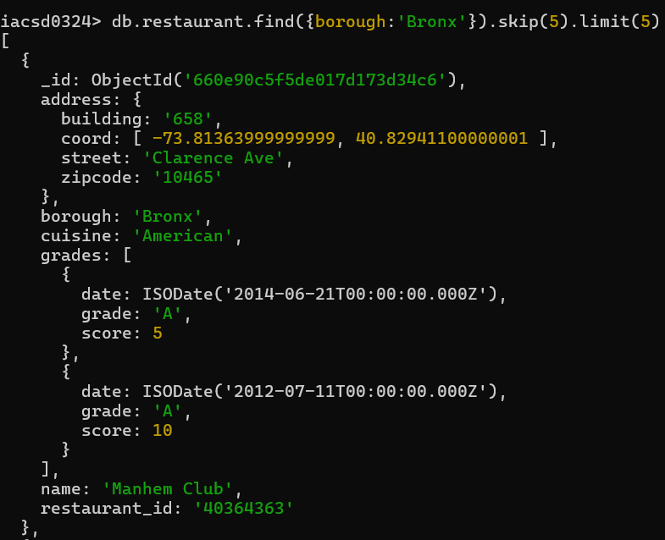

8. Write a MongoDB query to find the restaurants who achieved a score more than 90.

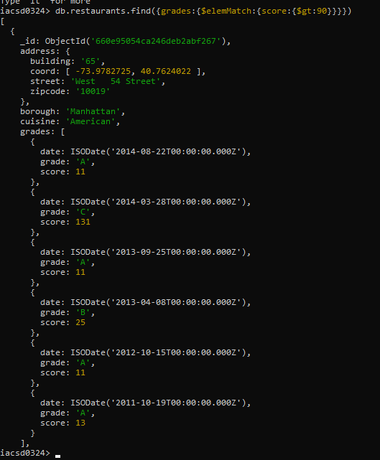

9. Write a MongoDB query to find the restaurants that achieved a score, more than 80 but

less than 100.

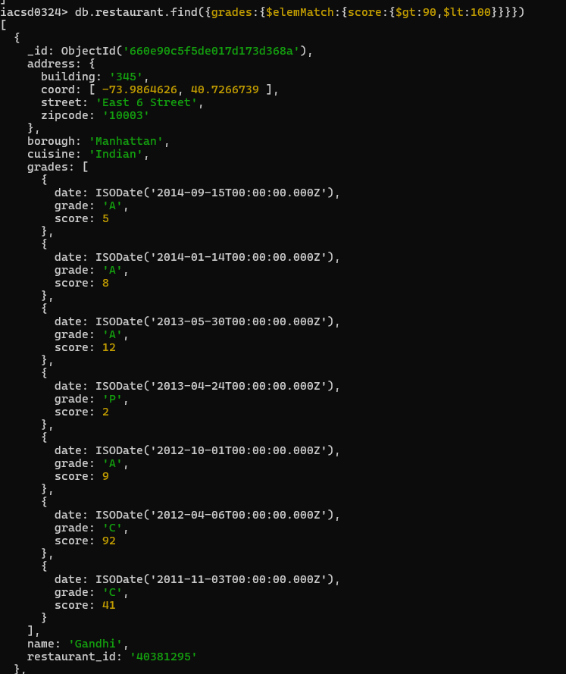y

10. Write a MongoDB query to find the restaurants which locate in latitude value less than -

95.754168.

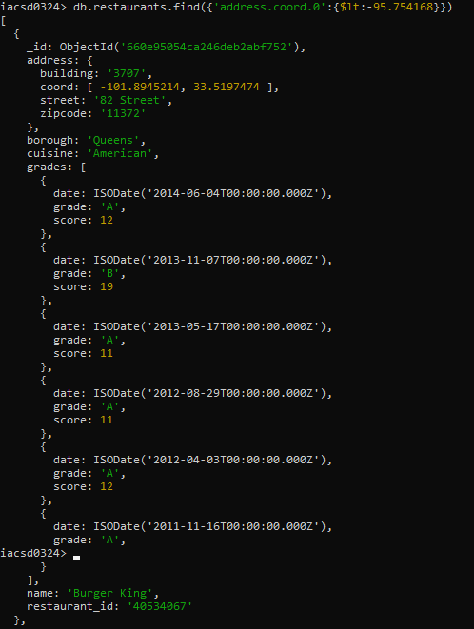

11. Write a MongoDB query to find the restaurants that do not pre-pare any cuisine of

'American' and their grade score more than 70 and latitude less than -65.754168.

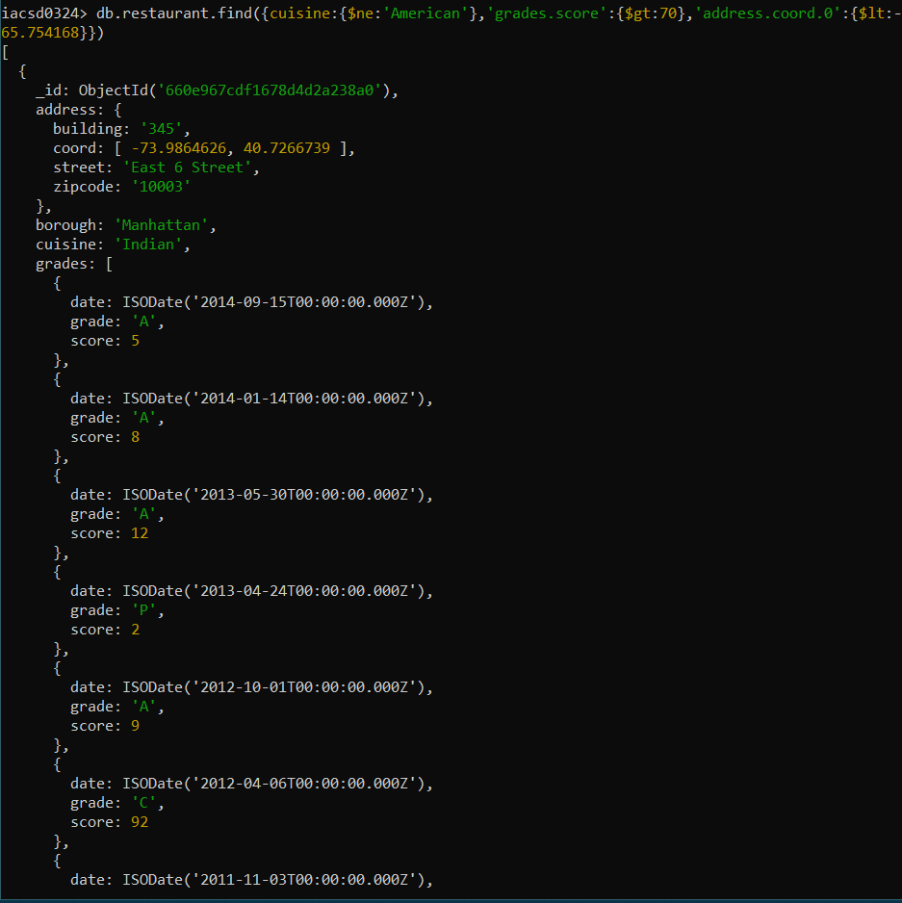

12. Write a MongoDB query to find the restaurants which do not prepare any cuisine of

'American' and achieved a score more than 70 and located in the longitude less than -

65.754168.

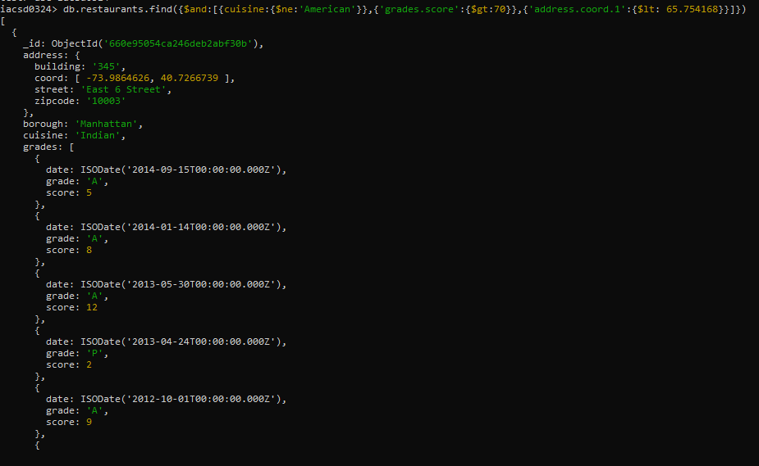

13. Write a MongoDB query to find the restaurants belongs which do not prepare any cuisine of

'American ' and achieved a grade point 'A' not to the borough Brooklyn. The

document must be displayed according to the cuisine in descending order.

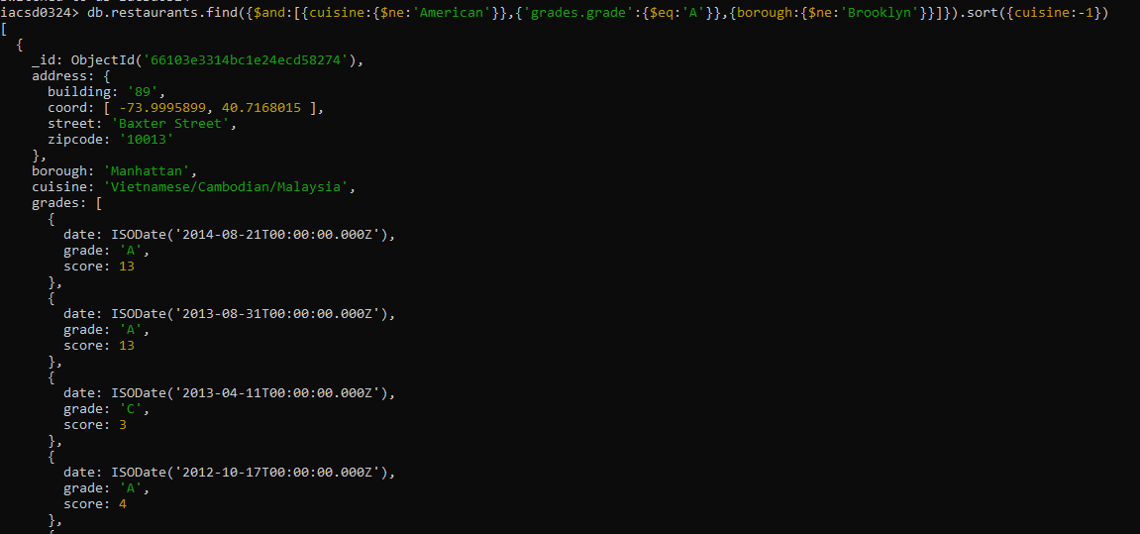

14. Write a MongoDB query to find the restaurant Id, name, borough and cuisine for those

restaurants which contain 'Wil' as first three letters for its name.

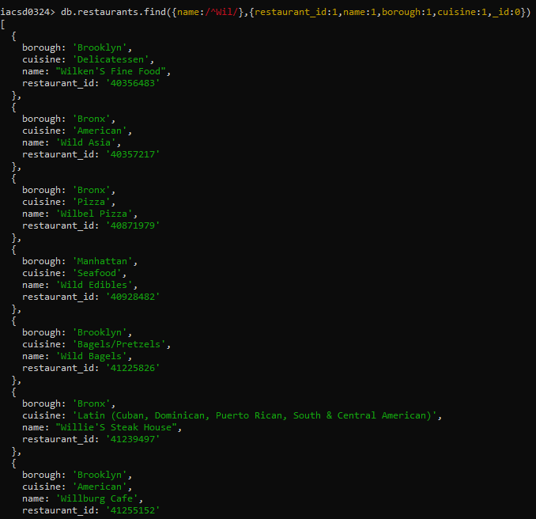

15. Write a MongoDB query to find the restaurant Id, name, borough and cuisine for those

restaurants which contain 'ces' as last three letters for its name.

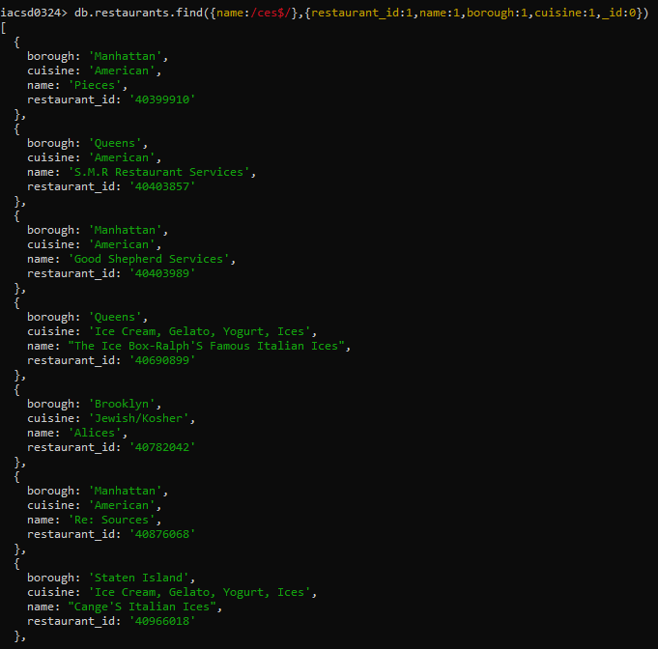

16. Write a MongoDB query to find the restaurant Id, name, borough and cuisine for those

restaurants which contain 'Reg' as three letters somewhere in its name.

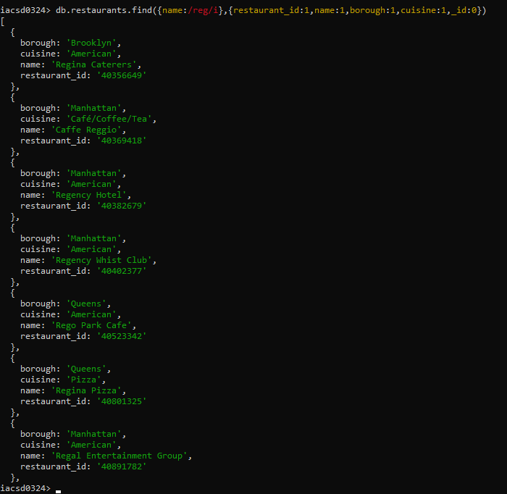

17. Write a MongoDB query to find the restaurants which belong to the borough Bronx and

prepared either American or Chinese dish.

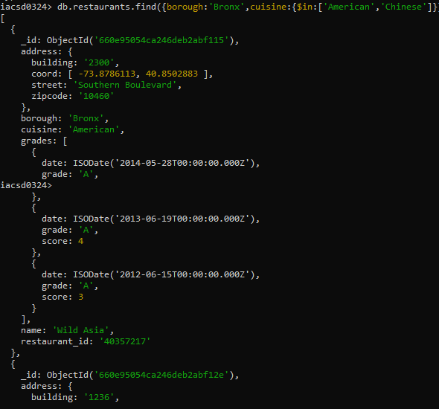

18. Write a MongoDB query to find the restaurant Id, name, borough and cuisine for those

restaurants which belong to the borough Staten Island or Queens or Bronxor Brooklyn.

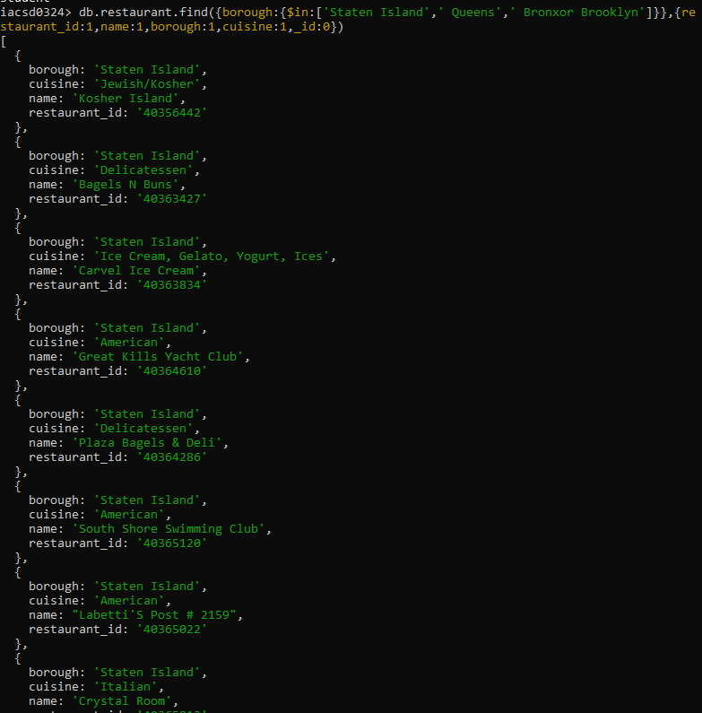

19. Write a MongoDB query to find the restaurant Id, name, borough and cuisine for those

restaurants which are not belonging to the borough Staten Island or Queens or Bronxor

Brooklyn.

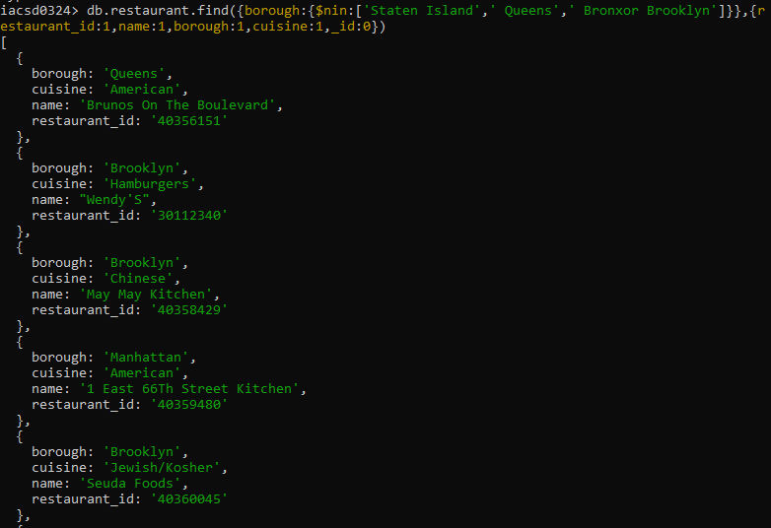

20. Write a MongoDB query to find the restaurant Id, name, borough and cuisine for those

restaurants which achieved a score which is not more than 10.

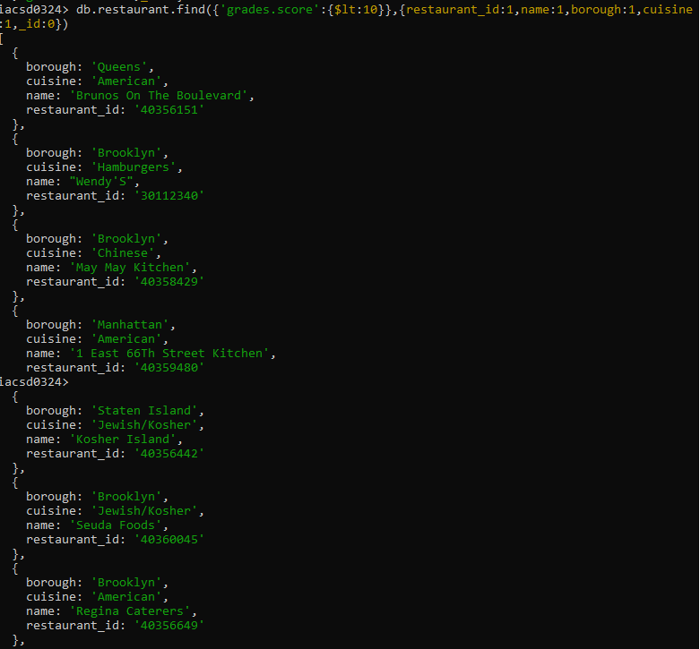

21. Write a MongoDB query to find the restaurant Id, name, borough and cuisine for those

restaurants which prepared dish except 'American' and 'Chinees' or restaurant's name begins

with letter 'Wil'.

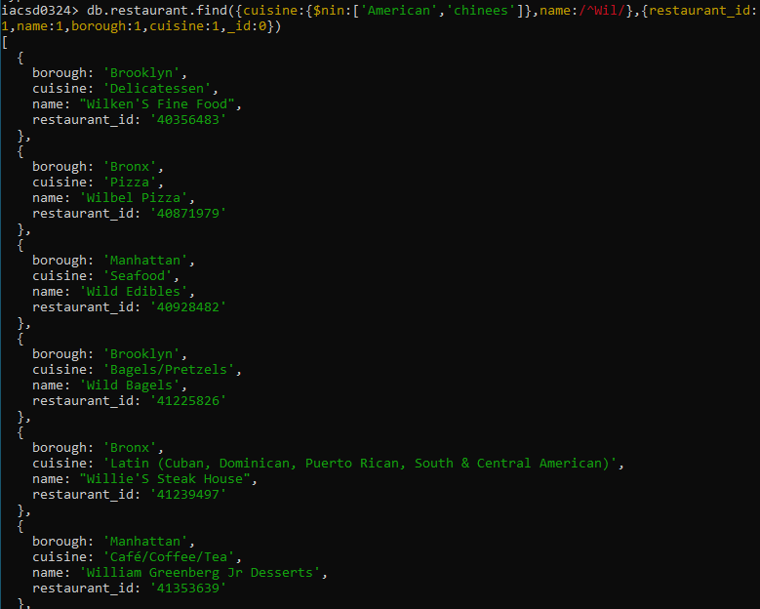

22. Write a MongoDB query to find the restaurant Id, name, and grades for those restaurants

which achieved a grade of "A" and scored 11 on an ISODate "2014-08-11T00:00:00Z"

among many of survey dates

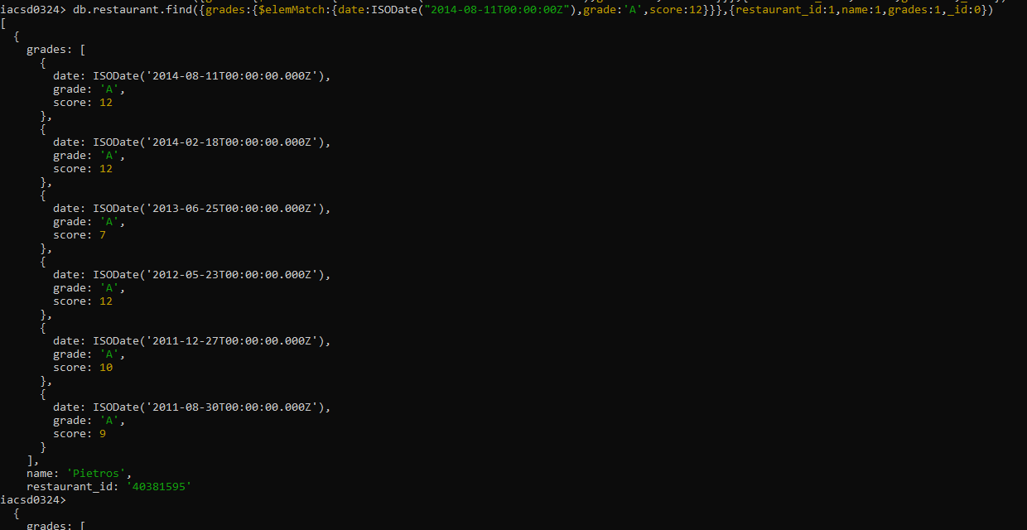

23. Write a MongoDB query to find the restaurant Id, name and grades for those restaurants

where the 2nd element of grades array contains a grade of "A" and score 9 on an ISODate

"2014-08-11T00:00:00Z".

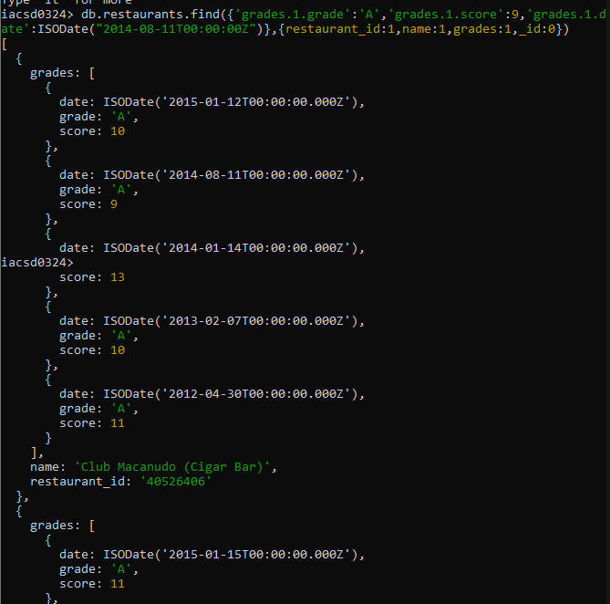

24. Write a MongoDB query to find the restaurant Id, name, address and geographical

location for those restaurants where 2nd element of coord array contains a value which is

more than 42 and upto 52

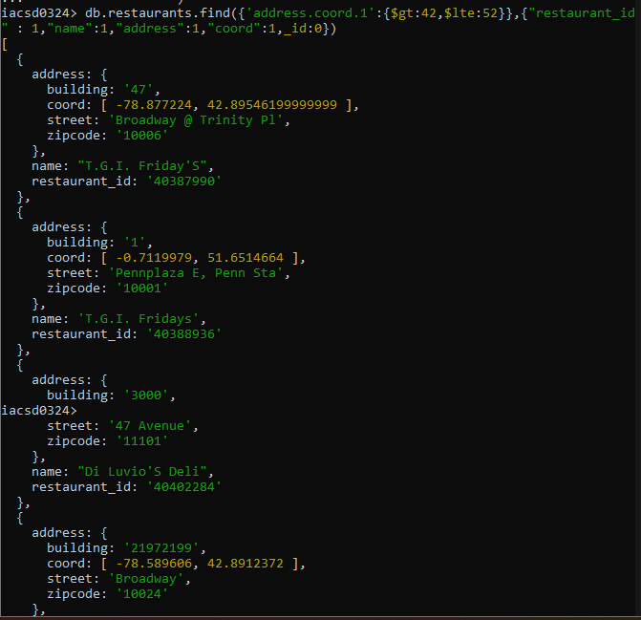

25. Write a MongoDB query to arrange the name of the restaurants in ascending order along

with all the columns.

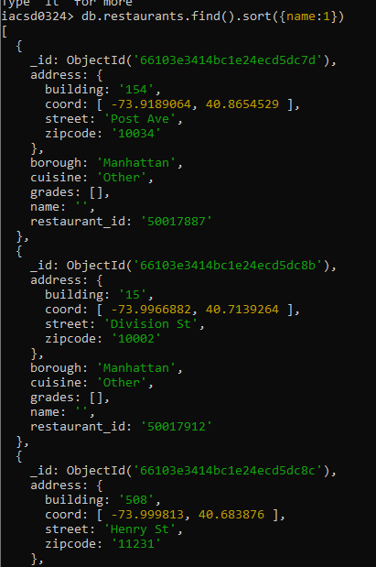

26. Write a MongoDB query to arrange the name of the restaurants in descending along with

all the columns.

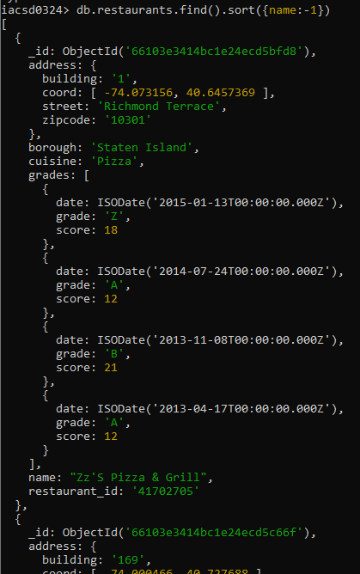

27. Write a MongoDB query to arranged the name of the cuisine in ascending order and for

that same cuisine borough should be in descending order.

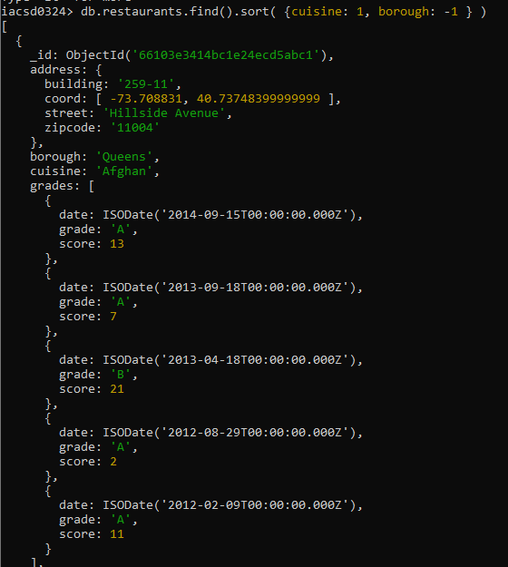

28. Write a MongoDB query to know whether all the addresses contains the street or not.

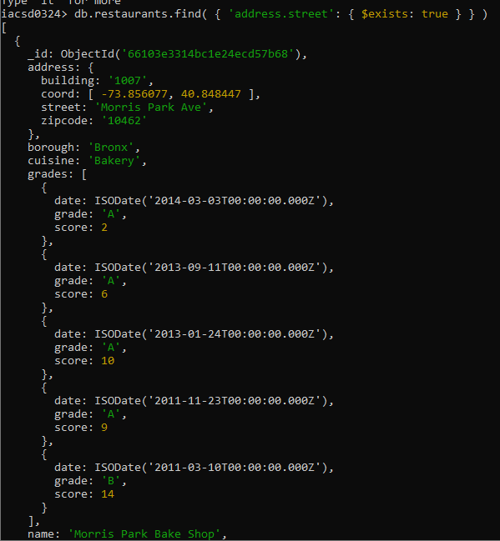

29. Write a MongoDB query which will select all documents in the restaurants collection

where the coord field value is Double.

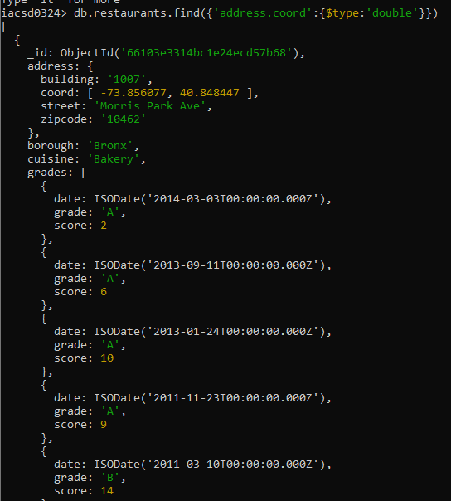

30. Write a MongoDB query which will select the restaurant Id, name and grades for those

restaurants which returns 0 as a remainder after dividing the score by 7.

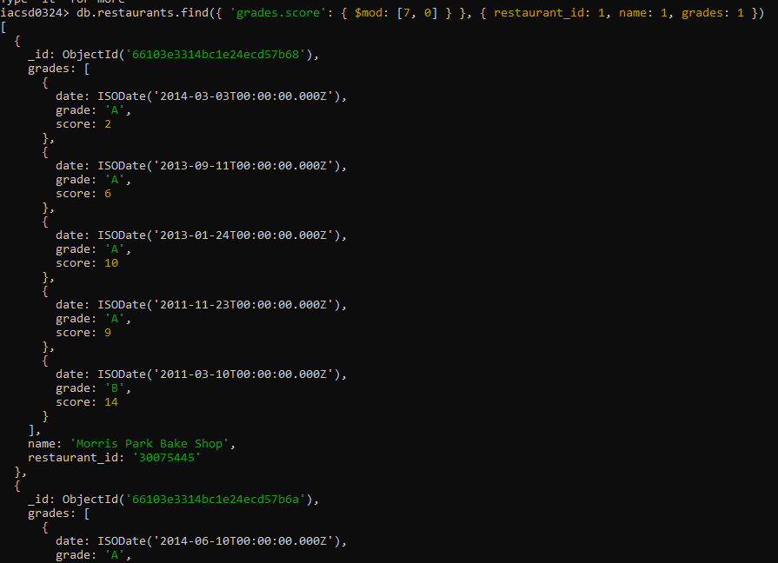

31. Write a MongoDB query to find the restaurant name, borough, longitude and attitude and

cuisine for those restaurants which contains 'mon' as three letters somewhere in its name.

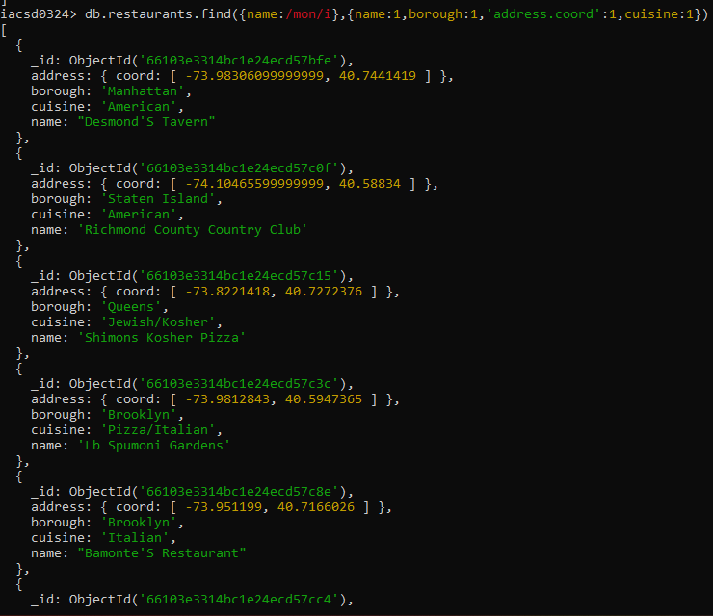

32. Write a MongoDB query to find the restaurant name, borough, longitude and latitude and

cuisine for those restaurants which contain 'Mad' as first three letters of its name.

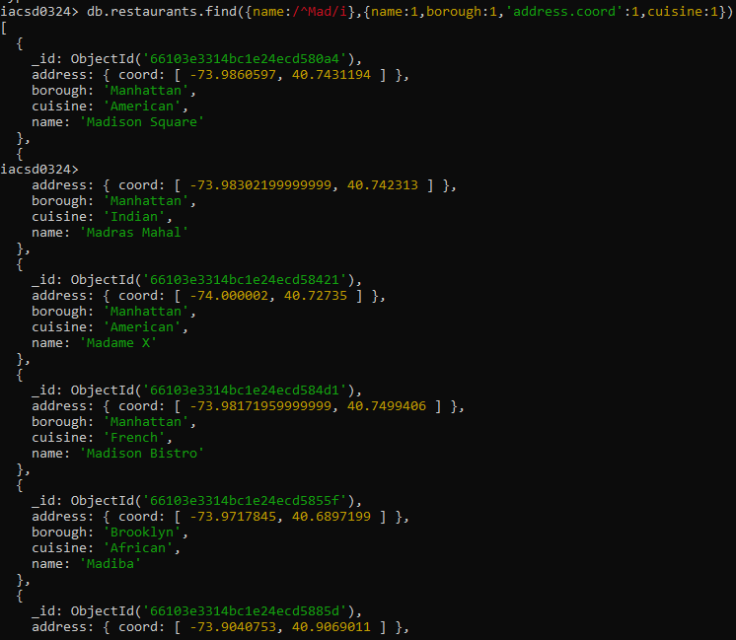

**Mongodb-Books Assignment**

1. Find all books whose author is Faisal Abid and display name of book authors and

categories

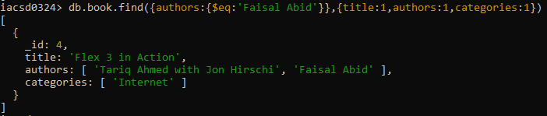

2. List all the books with category Internet at first position in category array

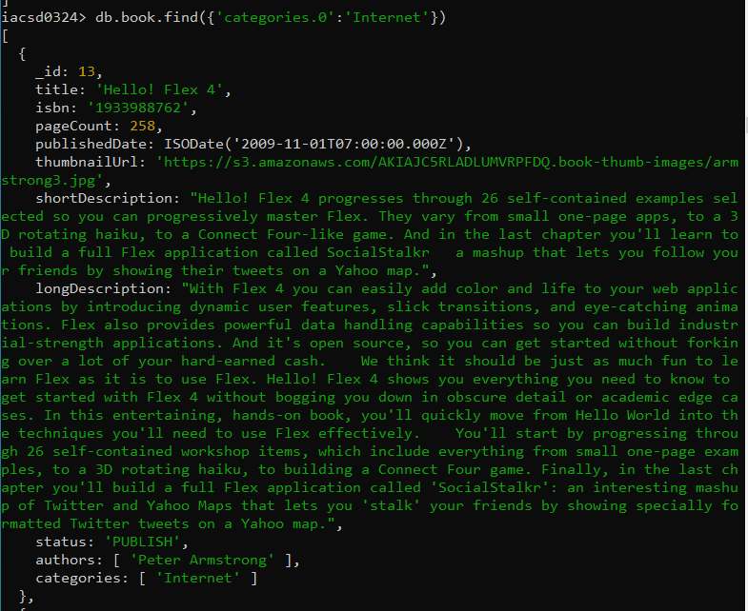

3. Change the status of books “undergoing change” for books having more than 500

pages and published in 2009

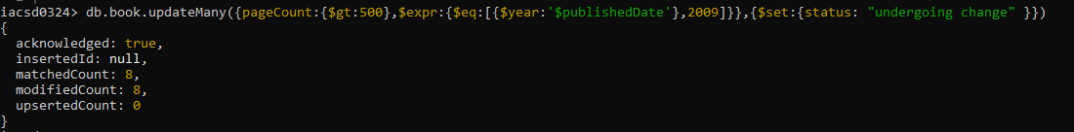

4. Find all the books containing word highlighting and depth in long description of the

book



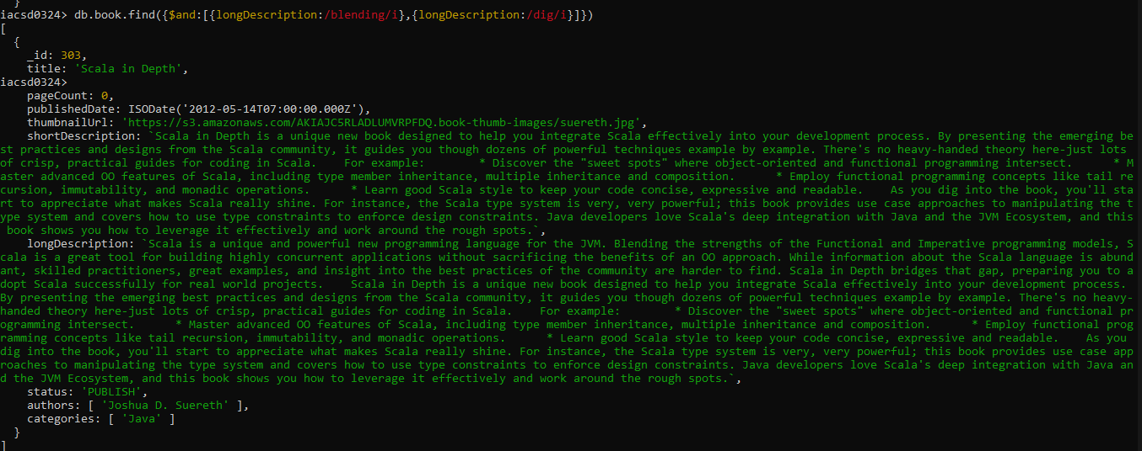

5. Display all books published in 2009

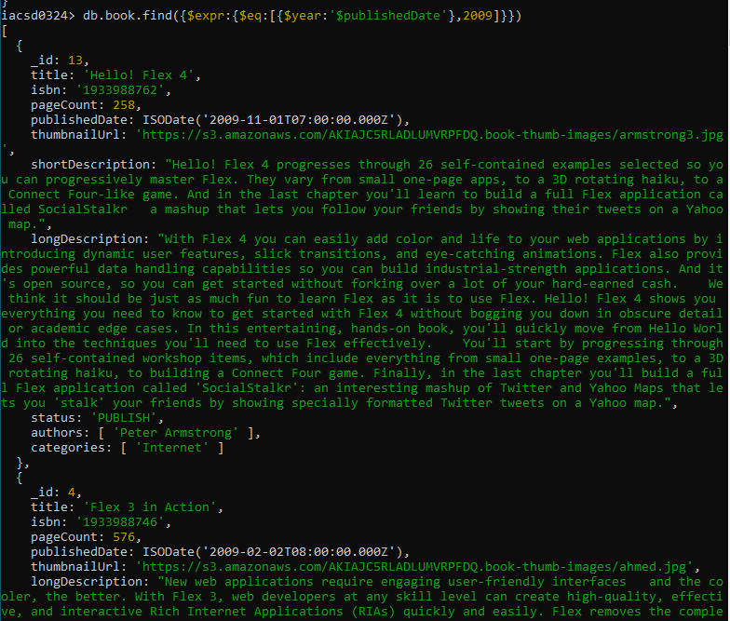

6. Find all books with pageCount is either 500 or 556 or 670

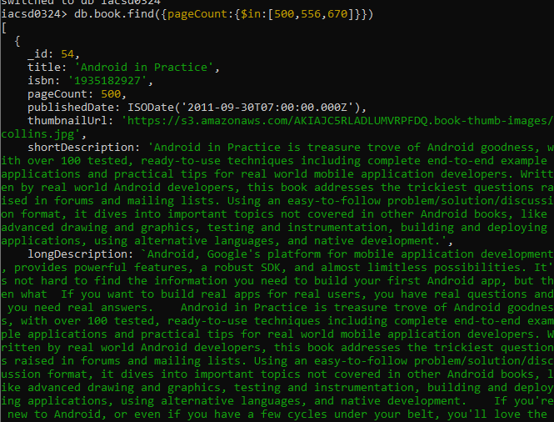

7. Add 2 categories “kindle” and “hard bind” in all the books if its pageCount >200 and

< 500 or number of pages >500

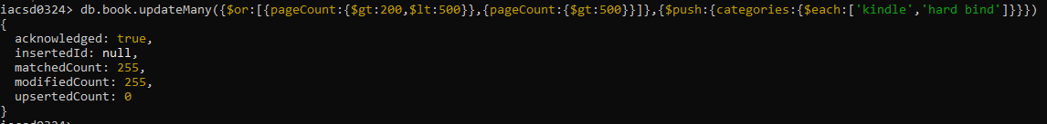

8. List all the books which has thumbnailUrl key

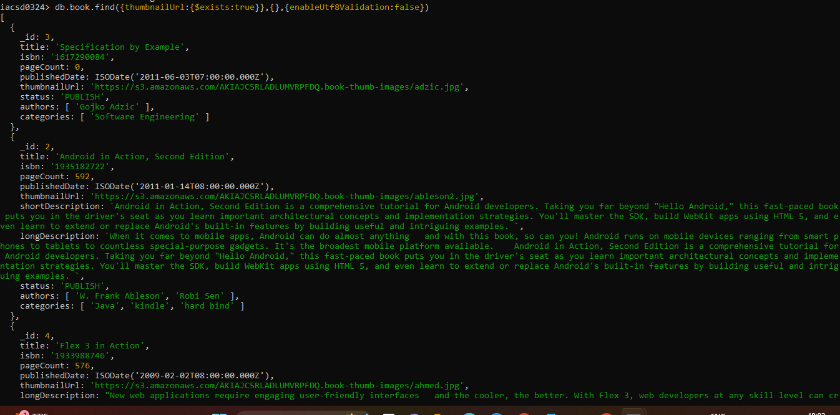

9. Add key type with values [“fiction”,”moral stories”,”adventurous”] in all books

whose title starts with Fl and contains a some where in the name

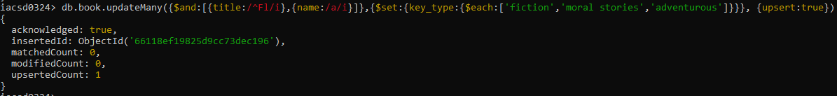

10. Add a key comments :[{comment:” like the book” ,date:ISODate(“2019-09-01”)},

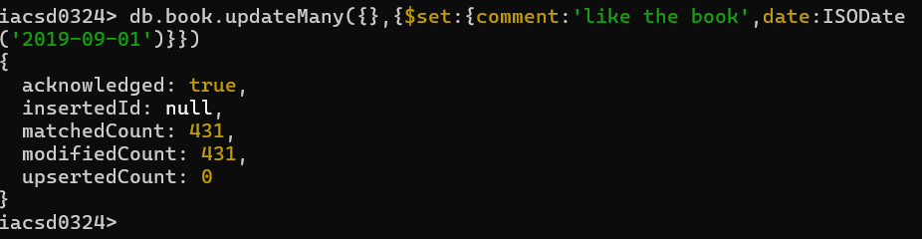

11. Add new author “myauthor” at position 2 for all books whose title starts with h or m

and contains s at 2nd last position

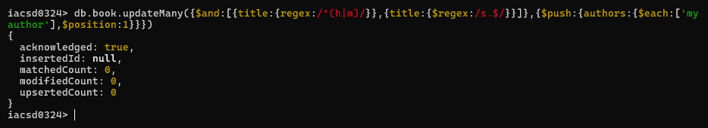

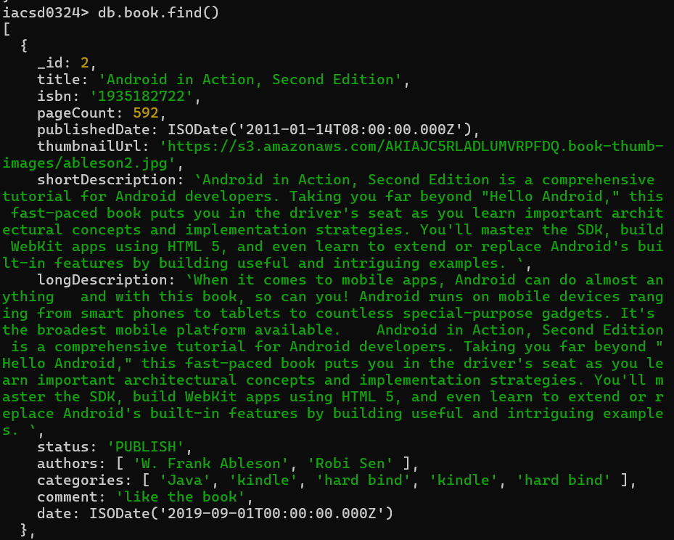

12. Increase pageCount by 100 for all books whose author at 1 st position is “Gal

Shachor”

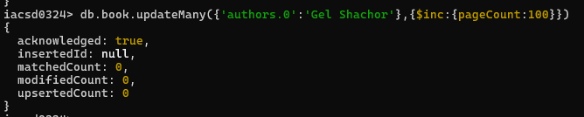

13. Overwrite “Magnus Rydin" with name “Fr”

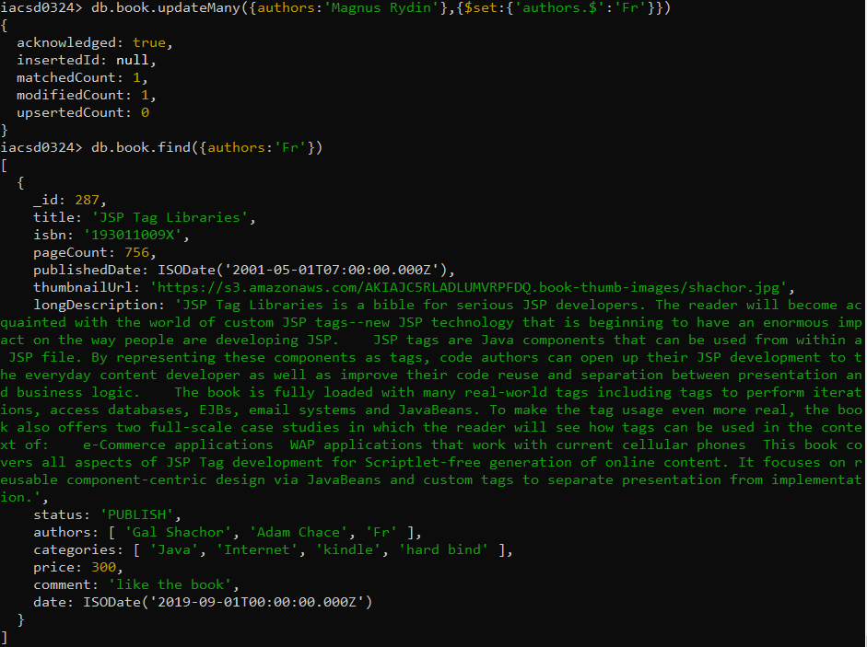

14. List all books title, status, pageCount, comments for all books with pages > 300 or <

500 or title starts with a or isbn starts with 193

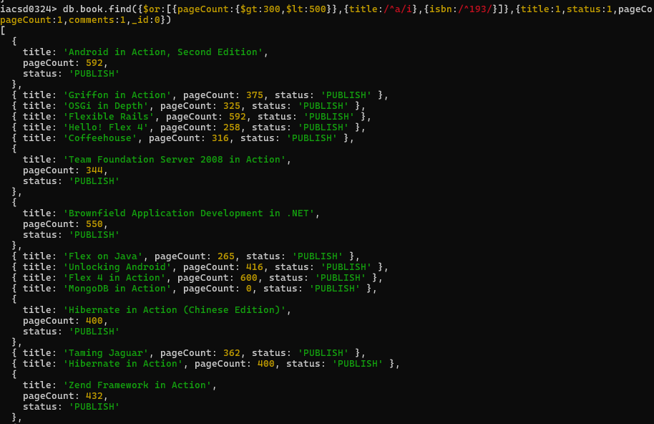

3. **EMPLOYEE ASSIGNMENT**

Create a Employee Collection add 5 documents:

Example:

{emono:111,ename:”Deepali

Vaidya”,sal:40000.00,dept:{deptno:12,dname:,”Hr”,dloc:”Mumbai},

Desg:”Analyst”,mgr:{name:”Satish”,num:111},project:[{name:”Project-

1”,Hrs:4},{name:”project- 2”,Hrs:4}]}

s.

Update the Employee collection for this.

2. Change the number of hours for project-1 to 5 for all employees with designation analyst.

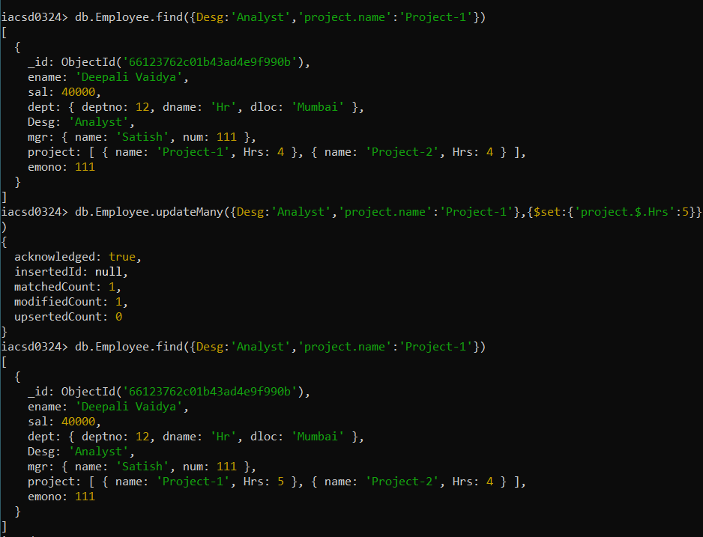

3. Add 2 projects project-3 and project-4 for employee whose name starts with ”Deep” with 2 hrs

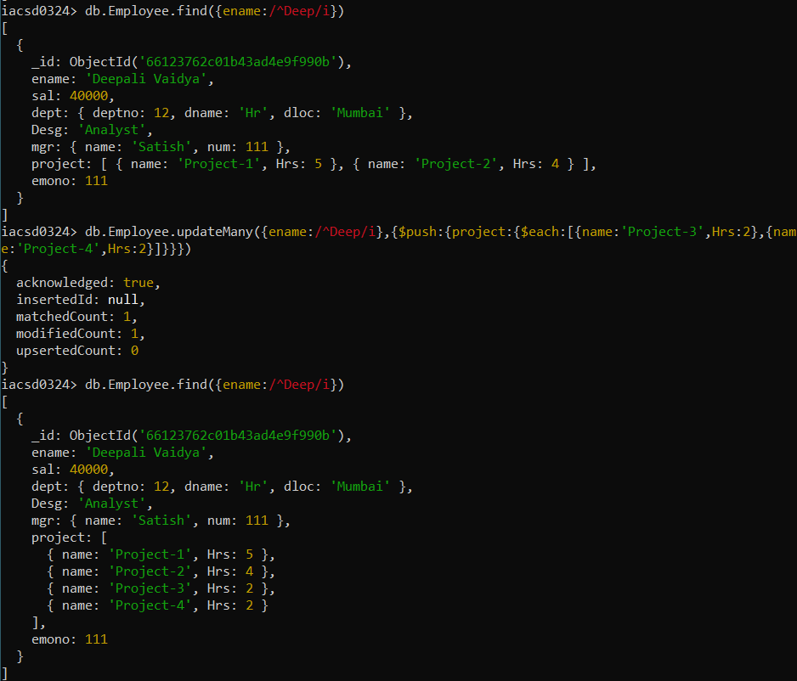

db.emp.update({name:/^Deep/},{$push:{project:{$each:[{name:'project-

3',Hrs:2},{name:'project-4',Hrs:2}]}}},

{multi:true})

4. Add bonus rs 2000 for all employees with salary > 50000

5. add bonus 1500 if salary <50000 and > 30000

6. add bonus 1000 if salary <=30000

7. Change manager name to Tushar for all employees whose manager is currently “satish”

And manager number to 3333

8. Increase salary of all employees from “purchase department” by 15000

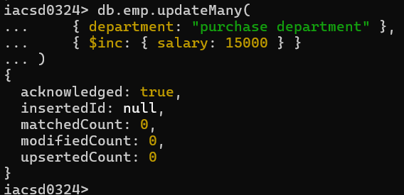

9. Decrease number of hrs by 2 for all employees who are working on project-2

Delete project-2 from all employee document if they are working on the project for 4 hrs.

db.emp.update({},{$pull:{“project.name”:”project-

2”,”project.Hrs”:4}},{multi:true})

or

db.Emp.update({},{$pull:{project:{name:'project-2',Hrs:4}}},{multi:true}) or

db.emp.update({},{$pull:{“project:{$elemMatch:{name:”project- 2”,”Hrs”:4}},{multi:true})

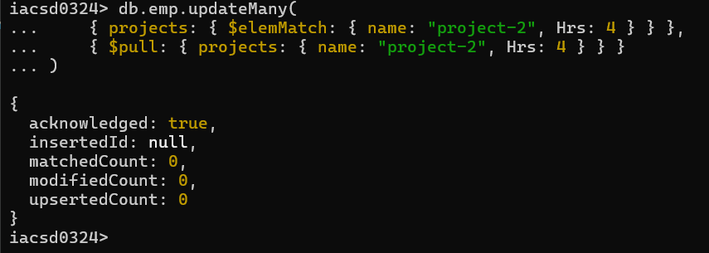

Change the salary of employees to 10000 only if their salary is < 10000

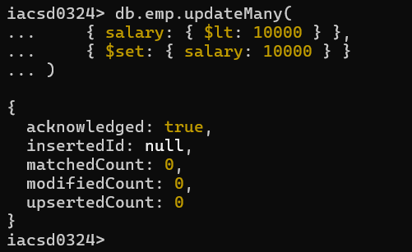

Increase bonus of all employees by 500 if the bonus is <2000 or their salary is < 20000 or if employee belong to sales department

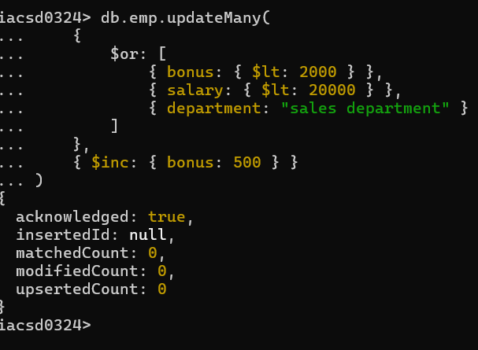

Add 2 new project at position 2 for all employees with designation analyst or salary is equal to either 30000 or 33000 or 35000

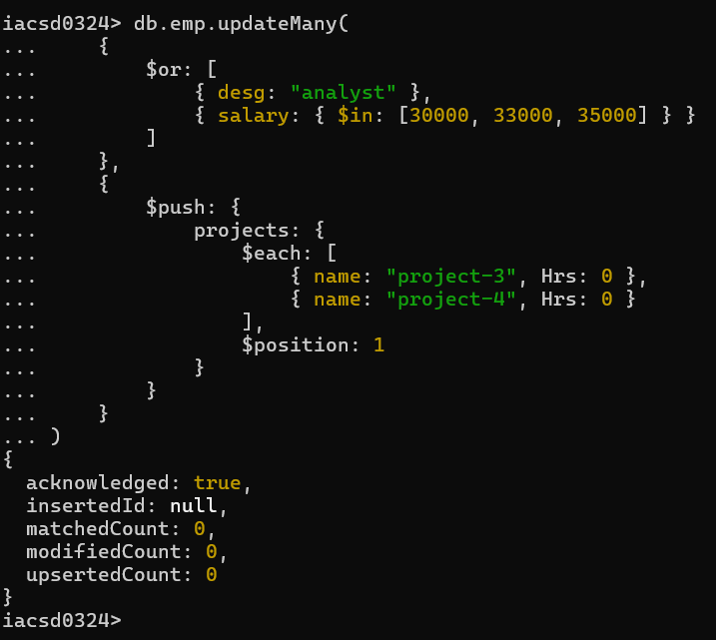

Delete last project of all employees with department name is “HR” and if the location is Mumbai

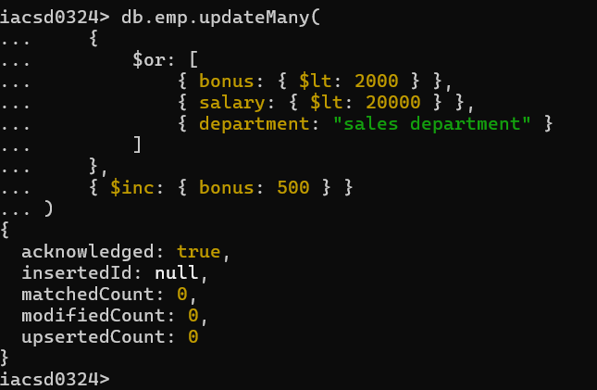

Change designation of all employees to senior programmer if they are working on name:”Project-1” for 4 hrs

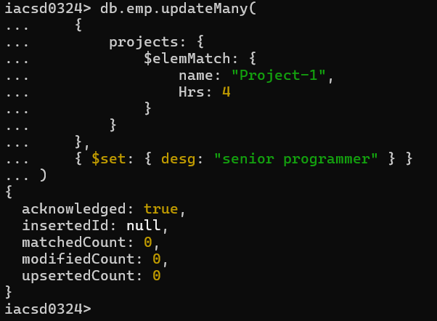

Add list of hobbies in all employees document whose manager is Rajan or Revati

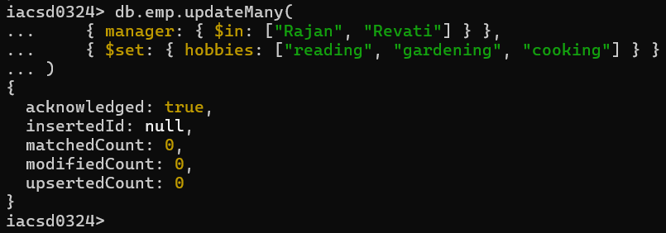

Add list of skillset in all employee documents who are working on project-4 for 3 hrs or on project-3 for 4 hrs

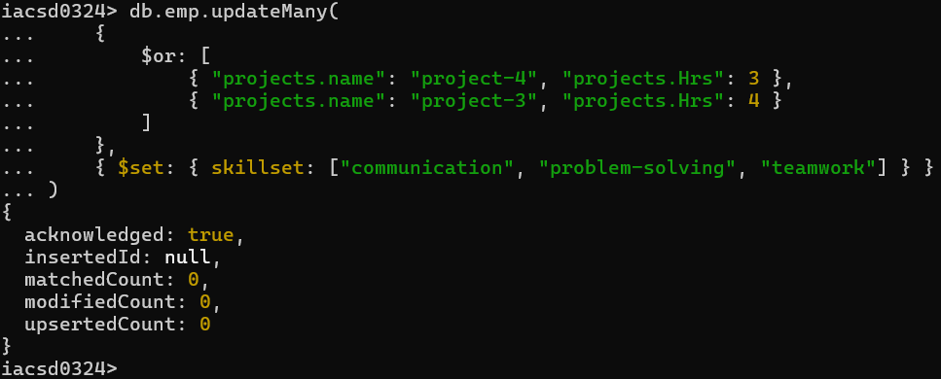

Add a new hobby as blogging at 3 position in hobbies array for all

employess whose name starts with R or p and ends with j or s

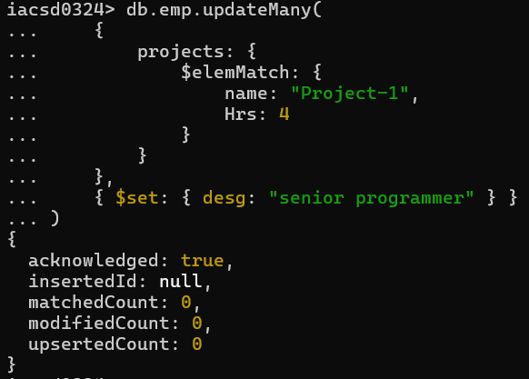

Increase salary by 10000 for all employees who are working on project-2 or project-3 or project-1

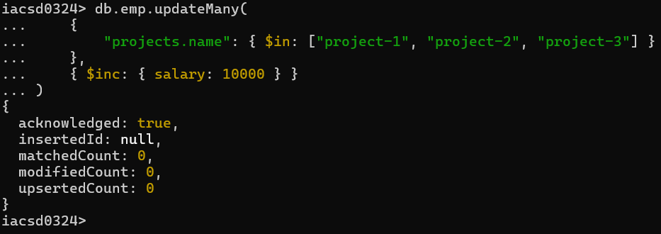

Remove all employees working on project-1

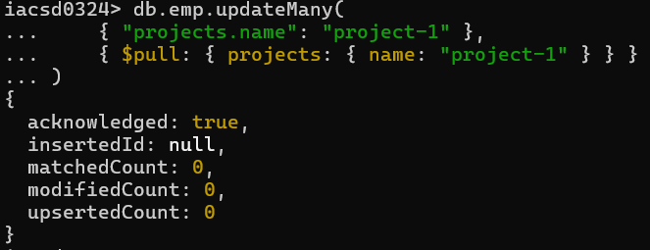

Replace document of employee with name “Deepak to some new document

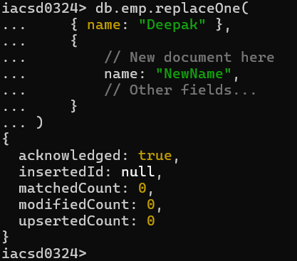

Change skill python to python 3.8 for all employees if python is there in the skillset

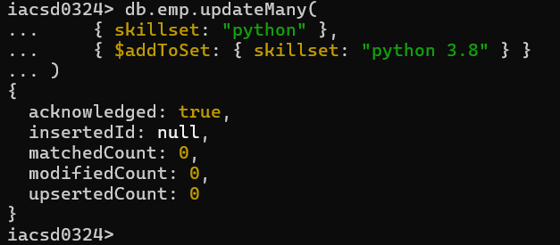

Add 2 skills MongoDb and Perl at the end of skillset array for all employees who are working at Pune location

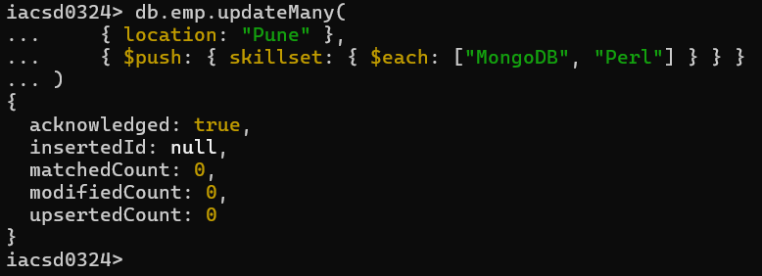

Delete first hobby from hobby array for all employees who are working on project-1 or project-2

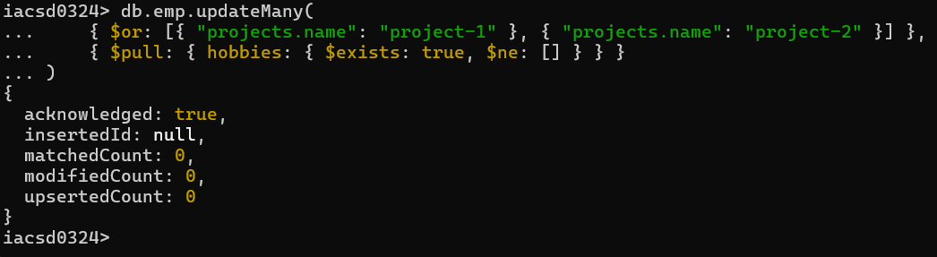

Delete last hobby from hobbies array for all employees who are working on project which is at 2 nd position in projects array for 4 hrs

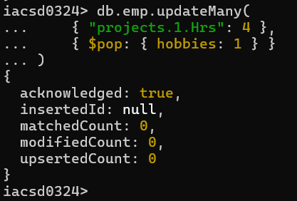

Add 2 new projects at the end of array for all employees whose skillset contains Perl or python

